
绝密★启用前
2015年普通高等学校 招生全国统一考试（安徽卷）
英语
本试卷分第Ⅰ卷(选择题)和第Ⅱ卷(非选择题)两部分。全卷满分150分，考试时间120分钟。
考生注意事项：
1．答题前，务必在试题卷、答题卡规定的地方填写自己的姓名、座位号，并认真核对答题卡上所粘贴的条形码中姓名、座位号与本人姓名、座位号是否一致。务必在答题卡背面规定的地方填写姓名和座位号后两位。
2．答第Ⅰ卷时，每小题选出答案后，用2B铅笔把答题卡上对应题目的答案标号涂黑。如需改动，用橡皮擦干净后，再选涂其他答案标号。
3．答第Ⅱ卷时，必须使用0．5毫米的黑色墨水签字笔在答题卡上书写，要求字体工整、笔迹清晰。作图题可先用铅笔在答题卡规定的位置绘出，确认后再用0．5毫米的黑色墨水签字笔描清楚。必须在题号所指示的答题区域作答，超出答题区域书写的答案无效，在试题卷、草稿纸上答题无效。
4．考试结束，务必将试题卷和答题卡一并上交。
第Ⅰ卷
第二部分 英语知识运用（共两节，满分45分）
- 单项填空（共15小题；每小题1分，满分15分）
从A、B、C、D四个选项中，选出可以填入空白处的最佳选项，并在答题卡上将该项涂黑。
例: It is generally considered unwise to give a child ______ he or she wants.
A. however B. whatever C. whichever D. whenever
答案是B
21. — Can you come to a party on Saturday, Peter?
— Oh, ______I'm already going out, I'm afraid.
- what a pity! B. don't ask! C. how come? D. so what?
【答案】A
【解析】
试题分析：句意：--皮特，你周六能来参加聚会吗？--噢，真遗憾！(到时候)恐怕我已经出去了。A真遗憾！；B别问了！；C怎么会？；D那又怎样？根据句意可知，这里指可能参加不了聚会，因此此处表示“遗憾”，故选A。
考点：考查交际用语
22.If you come to visit China, you will ______ a culture of amazing depth and variety.
A. develop B. create C. substitute D. experience
【答案】D
【解析】
试题分析：句意：如果你来中国旅游，你将会体验到一种有深度和多样化的文化。A发展，培养；B创造；C代替；D经历。故选D。
考点：考查动词辨析
23.______ scientists have learned a lot about the universe, there is much we still don't know.
A. Once B. Since C. Though D. Unless
【答案】C
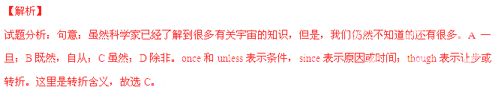考点：考查状语从句
24.Just as I got to the school gate, I realised I ______ my bank in the cafe.
A. have left B. had left C would leave D. was leaving
【答案】B
【解析】
试题分析：句意：我刚一到学校门口，就意识到我把书落在餐馆了。realized后省略了that，这里是一个宾语从句，从句时态与主句保持一致，“落下”的动作发生在“意识到”之前，应该用过去完成时，故选B。
考点：考查时态
25.A ship in harbor is safe, but that’s not ______ ships are built for.
A. what B. whom C. why D. when
【答案】A
【解析】
试题分析：句意：船停放在海港里是很安全的，但这并非建造船的目的。isn’t后跟从句作表语，表语从句中的for后缺少宾语，用what引导，what与for连用，表示目的。故选A。
考点：考查名词性从句
26.I’m so ______ to all those volunteers because they helped my terrible day end happily.
A. special B. superior C. grateful D. attractive
【答案】C
【解析】
试题分析：句意：我非常感激所有的志愿者，因为他们帮我把糟糕的一天变成了愉快的一天。A特殊的；B优秀的，比......好的；C感激的；D有吸引力的。根据句意可知，这里是在向志愿者表达感激之情，故选C。
考点：考查形容词辨析
27.______ the difference between the two research findings will be one of the worst mistakes you make.
A. Ignore B. Ignoring C. Ignored D. Having ignored
【答案】B
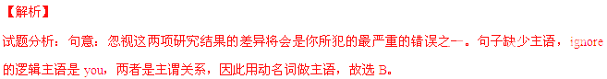考点：考查动名词作主语
28.Some experts think reading is the fundamental skill upon______school education depends.
A. it B. that C. whose D. which
【答案】D
【解析】
试题分析：句意：一些专家认为阅读是学校教育所依赖的基本技能。it不能引导定语从句；that不用于介词之后；whose作定语，其后需有名词；depend on/upon依靠，依赖，介词后只能用which或whom来构成定语从句的引导词，故选D。
考点：考查定语从句
29.It is reported that a space station ______ on the moon in years to come.
A. will be building B. will be built C. has been buildingD. has been built
【答案】B
【解析】
试题分析：句意：据报道，人们在接下来的几年里将在月球上建一个空间站。根据“in years to come”可知用将来时，space station和build是动宾关系，应该使用被动语态，故选B。
考点：考查时态
【名师点睛】本题考查时态。做时态类的题目，需要从句中找出时间状语，没有时间状语时，需要结合句意来判断。根据“in years to come”可知是将来的事情，且空间站是被建造的。
30.There is no need to tell me your answer now. Give it some ______ and then let me know.
A. thought B. support C. protection D. authority
【答案】A
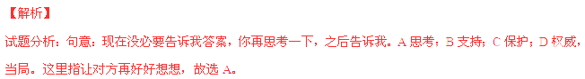考点：考查名词辨析
31.They gave money to the old people's home either ______ or through their companies.
A. legally B. sincerely C. personally D. deliberately
【答案】C
【解析】
试题分析：句意：他们给那位老人的家里送钱，有的是一个人的名义，有的则是通过他们的公司。A合法地；B真诚地；C亲自，当面地，个人而言；D故意地。故选C。
考点：考查副词辨析
32.It is lucky we booked a room, or we ______nowhere to stay now.
A. had B. had had C. would have D. would havehad
【答案】C
【解析】
试题分析：句意：我们很幸运地订到了房间，否则的话，我们现在就会无处可去了。or引导含蓄虚拟条件句，or后面是主句，相当于if we hadn’t booked a room, we would have nowhere to stay now.，根据“now”可知，是对现在进行虚拟，因此用would+动词原形，故选C。
考点：考查虚拟语气
33.They believe that there are transport developments ______ that will bring a lot of changes for the better.
A. out of date B. out of order C. around the clock D. around the comer
【答案】D
【解析】
试题分析：句意：他们认为即将到来的交通发展将会带来很多好的方面的变化。A过时的；B发生故障的；C昼夜不停地；D即将来临。故选D。
考点：考查介词短语
34.______ he once felt like giving up, he now has the determination to push further andkeep on going.
A. Where B. As C. In case D. Now that
【答案】A
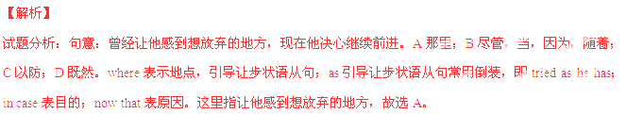考点：考查状语从句
35.— How is your table tennis these days? Still playing?
—______. I just don't seem to find the time these days.
A. That's right B. No, not much C That's great D. Don’t worry
【答案】B
【解析】
试题分析：句意：--你的乒乓球练得怎样了？还在练习吗？--没怎么练。我现在似乎没有时间练习。A是的，没错；B没，没怎么打；C真棒；D别担心。故选B。
考点：考查交际用语
第二节 完形填空（共20小题；每小题1.5分，满分30分）
阅读下面短文，从短文后各题所给的四个选项（A、B、C、和D）中，选出可以填入空白处的最佳选项，并在答题卡上将该项涂黑。
In our modern world, when something wears out, we throw it away and buy a new one. The 36 is that countries around the world have growing mountains of 37 because peopleare throwing out more rubbish than ever before.
How did we 38 a throwaway society? First of all, it is now easier to 39 an object than to spend time and money to repair it. 40 modern manufacturing (制造业) and technology, companies are able to produce products quickly and inexpensively. Products are plentiful and 41 .
Another cause is our42 of disposable (一次性的) products.As 43 people,we are always looking for 44 to save time and make our lives easier. Companies 45 thousands of different kinds of disposable products: paper plates, plastic cups, and cameras, to name a few.
Our appetite for new products also 46 to the problem. We are 47 buying new things. Advertisements persuade us that 48 is better and that we will be happier with the latest products. The result is that we 49 useful possessions to make room for new ones.
All around the world, we can see the 50 of this throwaway lifestyle. Mountains of rubbish just keep getting bigger. To 51 the amount of rubbish and to protect the 52 , more governments are requiring people to recycle materials. 53 , this is not enough to solve (解决) our problem.
Maybe there is another way out. We need to repair our possessions 54 throwing them away. We also need to rethink our attitudes about 55. Repairing our possessions and changing our spending habits may be the best way to reduce the amount of rubbish and take care of our environment.
36. A. key B. reason C. project D. problem
37. A. gifts B. rubbish C. debt D. products
38. A. face B. become C. observe D. change
39. A. hide B. control C. replace D. withdraw
40. A. Thanks to B. As to C. Except for D. Regardless of
41. A. safe B. funny C. cheap D. powerful
42. A. love B. lack C. prevention D. division
43. A. sensitive B. kind C. brave D. busy
44. A. ways B. places C. jobs D. friends
45. A. donate B. receive C. produce D. preserve
46. A. adapts B. returns C. responds D. contributes
47. A. tired of B. addicted to C. worried about D. ashamed for
48. A. newer B. stronger C. higher D. larger
49. A. pick up B. pay for C. hold onto D. throw away
50. A. advantages B. purposes C. functions D. consequences
51. A. show B. record C. decrease D. measure
52. A. technology B. environment C. consumers D. brands
53. A. However B. Otherwise C. Therefore D. Meanwhile
54. A. by B. in favour of C. after D. instead of
55. A. spending B. collecting C. repairing D. advertising
【答案】
36. D
37. B
38. B
39. C
40. A
41. C
42. A
43. D
44. A
45. C
46. D
47. B
48. A
49. D
50. D
51. C
52. B
53. A
54. D
55. C
【解析】
试题分析：文章主要讲的是堆积如山的垃圾给环境带来的影响。随着社会的发展，人们倾向于扔掉用旧了的东西，以新物品取而代之。而且，包装盒等一次性产品给人们带来方便的同时，也给环境带来很大的压力。
36. D 考查名词辨析。A答案；B原因；C项目；D问题。根据第二行“the world...”可知，出现的问题是垃圾堆积如山，故选D。
37. B 考查名词辨析。A礼物；B垃圾；C债务；D产品。句意：因为人们现在扔掉很多垃圾，因此，垃圾堆积成了山，故选B。
38. B 考查动词辨析。句意：A面对；B变得；C观察，庆祝；D改变。根据“first of all...”可知，这里讲的是乱扔垃圾的原因，故选B。
39. C 考查动词辨析。A躲藏；B控制；C代替；D撤退，收回。句意：与花时间和钱修理相比，现在更容易更换物品，故选C。
40. A 考查短语辨析。A多亏；B至于；C除了；D不管。句意：多亏了当代制造业和技术，公司能够更快地生产产品，成本也降低很多，故选A。
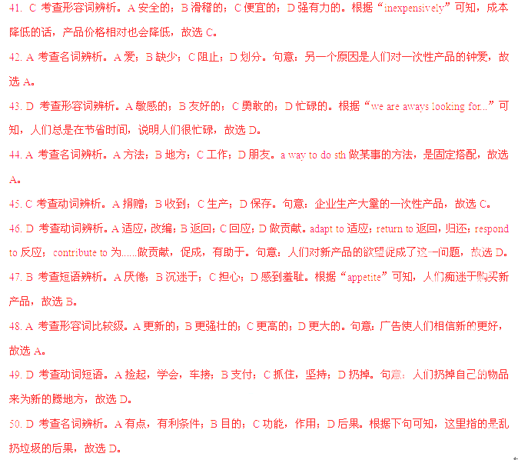

51. C 考查动词辨析。A显示，展示；B记录；C减少；D测量。句意：越来越多的政府要求人们循环使用物品，这样做是为了减少垃圾，故选C。
52. B 名词辨析。A技术；B环境；C消费者；D品牌。要求人们循环利用也是为了保护环境，故选B。
53. A 考查副词辨析。A然而；B要不然；C因此；D同时。句意：然而，只是要求人们循环利用是远远不够的，故选A。
54. D 考查介词辨析。A通过；B支持；C在......之后；D代替，而不是。句意：我们需要修理我们的财物，而不是扔掉它们，故选D。
55. C 考查动词辨析。A花费，度过；B收集；C修理；D宣传。句意：我们也需要重新考虑对修理的态度，根据下句“repairing...”可知答案，故选C。
考点：社会类短文阅读
第三部分阅 读理解(共20小题；每小题2分，满分40分)
阅读下列短文，从每题所给的四个选项(A、B、C和D)中，选出最佳选项，并在答
题卡上将该项涂黑。
A
Welcome to the Electronic Village to explore new ways of language teaching and learning.
Electronic Village Program (Thursday, June 18, 2015)
Nearpod  ❖9:00 am to 10:00 am  ❖Room 501  Nearpod is a software program that creates a rich context (语境) for students to learn vocabulary. The presenter will show how to use it. | TEO  ❖ 2:00 pm to 3:00 pm  ❖Room 502  Our students come from different backgrounds but have the same desire to learn on-line. The presenter will use examples from his first on-line class to explain how any teacher can begin teaching on-line with TEO.
Kahoot  ❖10:30 am to 11:30 am  ❖ Room 601  Kahoot software can be used to create grammar tests which can be graded on a network. It can provide students with instant feedback (反馈), including reports about their strengths and weaknesses. | Prezi  ❖3:30 pm to 4:20 pm  ❖Room 602  Uses of Prezi in listening and speaking courses draw students' attention to speaking more fluently. The presenter will show how students can use Prezi to confidently present on a variety of topics, including introducing family, friends, and hobbies.
56. Nearpod can be used to ______.
A. offer grammar tests B. teach listening on-line
C. help vocabulary learning D. gain fluency in speaking
57. If you want to improve your speaking skills, you can go to____________.
A. Room 501 B. Room 502 C. Room 601 D. Room 602
58. Which of the following can assess your grammar learning?
A. Nearpod. B. Kahoot. C. TEO. D. Prezi.
59. A teacher who wants to learn on-line teaching is expected to arrive by ______.
A. 9:00 am B. 10:30 am C. 2:00 pm D. 3:30 pm
【答案】
56. C
57. D
58. B
59. C
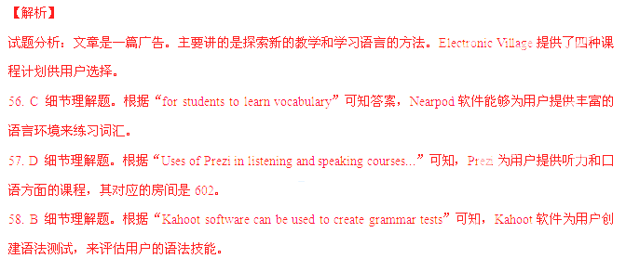

59. C 细节理解题。根据“The presenter will use examples from his first on-line class to explain how any teacher can begin teaching on-line with TEO.”可知，TEO的嘉宾将使用例子来解释如何进行网络教学，时间是下午两点到三点。
考点：广告类短文阅读
B
When her five daughters were young, Helene An always told them that there was strength in unity (团结). To show this, she held up one chopstick, representing oneperson. Then she easily broke it into two pieces. Next, she tied several chopsticks together, representing a family. She showed the girls it was hard to break the tied chopsticks. This lesson about family unity stayed with the daughters as they grew up.
Helene An and her family own a large restaurant business in California. However, when Helene and her husband Danny left their home in Vietnam in 1975, they didn't have much money. They moved their family to San Francisco. There they joined Danny's mother, Diana, who owned a small Italian sandwich shop. Soon afterwards, Helene and Diana changed the sandwich shop into a small Vietnamese restaurant. The five daughters helped in the restaurant when they were young. However, Helene did not want her daughters to always work in the family business because she thought it was too hard.
Eventually the girls all graduated from college and went away to work for themselves, but one by one, the daughters returned to work in the family business. They opened new restaurants in San Francisco and Los Angeles. Even though family members sometimes disagreed with each other, they worked together to make the business successful. Daughter Elisabeth explains, "Our mother taught us that to succeed we must have unity, and to have unity we must have peace. Without the strength of the family, there is no business."
Their expanding business became a large corporation in 1996, with three generations of Ans working together. Now the Ans' corporation makes more than $20 million each year. Although they began with a small restaurant, they had big dreams, and they worked together. Now they are a big success.
60. Helene tied several chopsticks together to show ______.
A. the strength of family unity B. the difficulty of growing up
C. the advantage of chopsticks D. the best way of giving a lesson
61. We can I earn from Paragraph 2 that the An family ______.
A. started a business in 1975 B. left Vietnam without much money
C. bought a restaurant in San Francisco D. opened a sandwich shop in Los Angeles
62. What can we infer about the An daughters?
A. They did not finish their college education.
B. They could not bear to work in the family business.
C. They were influenced by what Helene taught them.
D. They were troubled by disagreement among family members.
63. Which of the following can be the best title for the passage?
A. How to Run a Corporation B. Strength Comes from Peace
C. How to Achieve a Big Dream D. Family Unity Builds Success
【答案】
60. A
61. B
62. C
63. D
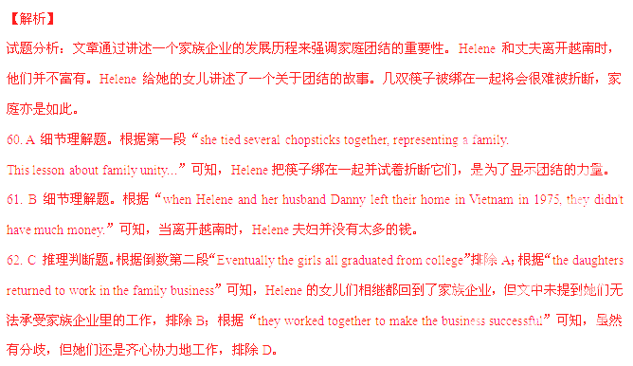63. D 选择最佳标题。根据第一段“Helene An always told them that there was strength in unity (团结).”和第三段“to succeed we must have unity”与第四段“and they worked together. Now they are a big success.”可知，文文章主要讲的是家庭团结对取得成功的重要性。文章没有讲怎样经营一家大型公司，也没有提到怎样实现伟大梦想。
考点：故事类短文阅读
C
As Internet users become more dependent on the Internet to store information, are people remember less? If you know your computer will save information, why store it in your own personal memory, your brain? Experts are wondering if the Internet is changing what we remember and how.
In a recent study, Professor Betsy Sparrow conducted some experiments. She and her research team wanted to know the Internet is changing memory. In the first experiment, they gave people 40 unimportant facts to type into a computer. The first group of people understood thatthe computer would save the information. The second group understood that the computer would not save it. Later, the second group remembered the information better. People in the first group knew they could find the information again, so they did not try to remember it.
In another experiment, the researchers gave people facts to remember, and told them where to find the information on the Internet. The information was in a specific computer folder (文件夹). Surprisingly, people later remember the folder location (位置) better than the facts. When people use the Internet, they do not remember the information. Rather, they remember how to find it. This is called "transactive memory (交互记忆)".
According to Sparrow, we are not becoming people with poor memories as a result of the Internet. Instead, computer users are developing stronger transactive memories; that is, people are learning how to organize huge quantities of information so that they are able to access it at a later date. This doesn't mean we are becoming either more or less intelligent, but there is no doubt that the way we use memory is changing.
64. The passage begins with two questions to ______.
A. introduce the main topic B. show the author's altitude
C. describe how to use the Interne. D. explain how to store information
65. What can we learn about the first experiment?
A. Sparrow's team typed the information into a computer.
B. The two groups remembered the information equally well.
C. The first group did not try to remember the formation.
D. The second group did not understand the information.
66. In transactive memory, people ______.
A. keep the information in mind B. change the quantity of information
C. organize information like a computer D. remember how to find the information
67. What is the effect of the Internet according to Sparrow's research?
A. Weare using memory differently. B. We arebecoming more intelligent.
C. We have poorer memories than before. D. We need a better way to access information.
【答案】
64. A
65. C
66. D
67. A
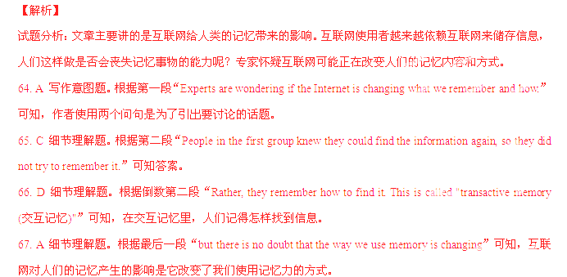考点：心理类短文阅读
D
There are an extremely large number of antsworldwide. Each individual (个体的) ant hardly weigh anything, but put together they weigh roughly the same as all of mankind. They also live nearly everywhere, except on frozen mountain tops and around the poles.Foranimals their size, ants have been astonishingly successful, largely due to their wonderfulsocial behavior.
In colonies (群体) that range in size from a few hundred to tens of millions, they organize their lives with a clear division of labor. Even more amazing is how they achievethis level of organization. Where we use sound and sight to communicate, ants dependprimarily on pheromone (外激素), chemicals sent out by individuals and smelled or tastedby fellow members of their colony. When an ant finds food, it produces a pheromone that will lead others straight to where the food is. When an individual ant comes under attack or is dying, it sends out an alarm pheromone to warn the colony to prepare for a conflict as a defense unit.
In fact, when it comes to the art of war, ants have no equal. They are completely fearless and will readily take on a creature much larger than themselves, attacking in large groups and overcoming their target. Such is their devotion to the common good of the colony that not only soldier ants but also worker ants will sacrifice their lives to help defeat an enemy.
Behaving in this selfless and devoted manner, these little creatures have survived on Earth, for more than 140 million years, far longer than dinosaurs. Because they think as one, they have a collective (集体的) intelligence greater than you would expect from itsindividual parts.
68. We can learn from the passage that ants are ____________.
A. not willing to share food
B. not found around the poles
C. more successful than all other animals
D. too many to achieve any level of organization
69. Ants can use pheromones for______.
A. escape B. communication C. warning enemies D. arranging labor
70. What does the underlined expression "take on" in Paragraph 3 mean?
A. Accept. B. Employ. C. Play with. D. Fight against.
71. Which of the following contributes most to the survival of ants?
A. Their behavior. B. Their size. C. Their number. D. Their weight
【答案】
68. B
69. B
70. D
71. A
【解析】
试题分析：文章主要讲的是蚂蚁。单个的蚂蚁显得微不足道，但成群结队的蚂蚁却蕴含着巨大的力量。蚂蚁的数量之众，加起来可以与人类的重量相媲美。蚂蚁分布极为广泛，除了寒冷的山顶和两极地区，几乎到处都有它们的踪影。
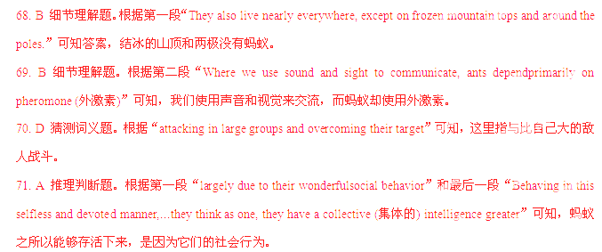考点：自然类短文阅读
E
Food serves as a form of communication in two fundamental ways. Sharing bread or other foods is a common human tradition that can promote unity and trust. Food can also have a specific meaning, and play a significant role in a family or culture's celebrations or traditions. The foods we eat—and when and how we eat them—are often unique to a particular culture or may even differ between rural (农村的) and urban areas within one country.
Sharing bread, whether during a special occasion (时刻) or at the family dinner table, is a common symbol of togetherness. Many cultures also celebrate birthdays and marriages with cakes that are cut and shared among the guests. Early forms of cake were simply a kind of bread, so this tradition hits its roots in the custom of sharing bread.
Food also plays an important role in many New Year celebrations. In the southern United States, pieces of corn bread represent blocks of gold for prosperity (兴旺) in the New Year. In Greece, people share a special cake called vasilopita. A coin is put into the cake, which signifies (预示) success in the New Year for the person who receives it.
Many cultures have ceremonies to celebrate the birth of a child, and food can play a significant role. In China, when a baby is one month old, families name and welcome their child in a celebration that includes giving red-colored eggs to guests. In many cultures, round foods such as grapes, bread, and moon cakes are eaten at welcome celebrations to represent family unity.
Nutrition is necessary for life, so it is not surprising that food is such an important part of different cultures around the world.
72. According to the passage, sharing bread______.
A. indicates a lack of food B. can help to develop unity
C. is a custom unique to rural areas D. has its roots in birthday celebrations
73. What does the coin in vasilopita signify for its receiver in the New Year?
A. Trust. B. Success. C. Health. D. Togetherness.
74. The author explains the role of food in celebrations by______.
A. using examples B. making comparisons
C. analyzing causes D. describing processes
75. What is the passage mainly about?
A. The custom of sharing food. B. The specific meaning of food.
C. The role of food in ceremonies. D. The importance of food in culture.
【答案】
72. B
73. B
74. A
75. D
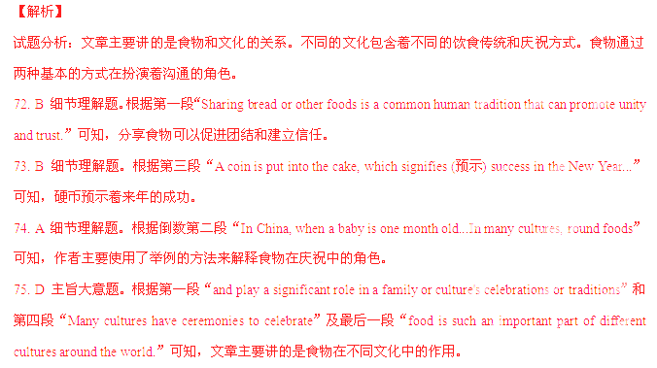考点：社会类短文阅读
第Ⅱ卷
考生注意事项：
请用0.5毫米黑色墨水签字笔在答题卡上作答，在试题卷上答题无效。
第四部分写作(共两节，满分35分)
第一节任务型读写(共10小题；每小题1分，满分10分)
阅读下面短文，根据所读内容在表格中的空白处填入恰当的单词。注意：每个空格只填一个单词。
Put a group of strangers in a room together, and they'll probably start a conversation. "Hot today, isn't it?"one might say. "You said it." another replies.
Why do we talk so much about the weather? When we meet new people, we don't begin by telling them our life story. We start with small talk, a polite conversation about something like traffic or weather.
Research suggests that small talk can build new friendships. When we begin conversations with new people, we want to feel comfortable, and so do they. We use small talk to find common interests. Once we have a common interest, a friendship can begin.
Small talk even helps people get hired. In order to impress at a job interview, you need to bond with the interviewer right away. Proper small talk can make that first impression get you the job.
So, how can you make small talk lead to a new friendship or job? First off, find common ground. Select something around you that you share with the other person.
Next, keep the conversation going. Compliment (赞美) the other person to make himor her feel comfortable, and ask questions to show interest.
Third, keep eye contact (接触). When you look people in the eye, they feel you appreciate what they are saying. It makes you appear honest and builds trust.
Naturally, shy people might not have enough confidence to start up conversations with strangers. Talking to someone you don't know is not the easiest thing to do! Some experts say with more practice, small talk does get easier.
Some people avoid small talk because they dislike discussing things like traffic or weather. For them, they are just too small. However, when you think about it, small talk is anything but small. In fact, it is actually a very big deal!
Title | Small Talk: A Big (76)____
Introduction | We are likely to make small talk when we (77)____ meet people.
(78)____ | ❖ Small talk can help people form (79)____ friendships.
(78)____ | ❖Small talk can also help people get a (80)____.
Advice | ❖Find some topics (81)____ with the other person.
Advice | ❖Keep the talk going by making compliments and (82)____ questions. ❖Keep eye contact in conversation to build (83)____.
Advice | ❖(84)____ more in order to make small talk easier.
Conclusion | Small talk really (85)____ a lot to us.
【答案】
76. Deal
77. first
78. Advantages/Benefits
79. new
80. job/position/post
81. shared
82. asking/rasing
83. trust
84. Practice/Practise
85. matters/means
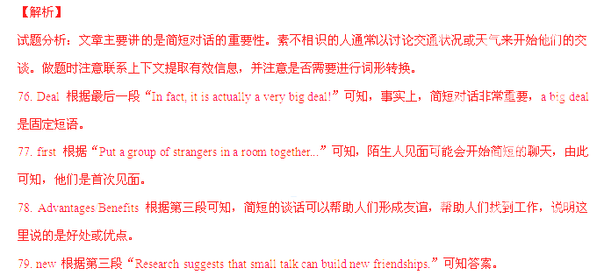

80. job/position/post 根据第四段“Proper small talk can make that first impression get you the job.”可知答案。
81. shared 根据第五段“Select something around you that you share with the other person.”可知答案，这里用过去分词作后置定语。
82. asking/rasing 根据第六段“and ask questions to show interest”可知，通过提问问题来表示自己感兴趣，by后跟动名词。
83. trust 根据第七段“It makes you appear honest and builds trust.”可知，眼神接触能使人显得真诚，并建立信任。
84. Practice/Practise 根据倒数第二段“Some experts say with more practice, small talk does get easier.”可知，简短对话经过多加练习之后就会变得容易。
85. matters/means 根据最后一段“small talk is anything but small. In fact, it is actually a very big deal!”可知，简短对话绝非不起眼，事实上，简短对话很重要。matter重要，相当于count。Mean a lot to sb对某人来说意义重大。
考点：社会类短文阅读
第二节 书面表达(满分25分）
86. 某英文杂志正在举办以"Fancy yourself as an interviewer"为主题的征文活动，请你以“A Famous Chinese I Would Like to Interview" 为题，写一篇英语短文。
内容包括：
1. 采访的对象；
2. 采访的原因；
3. 想提的问题。
注意：
1. 词数120左右；
2. 可以适当增加细节，以使行文连贯；
3. 短文中不能出现与本人相关的信息；
4. 短文的标题已给出，不计人总词数。
A Famous Chinese I Would Like to Interview
____________________________________________________________________________________________________________________________________________________________________________________________________________________________________
【参考答案】
A Famous Chinese I Would Like to Interview
The person I would like to interview is Yang Liwei.
I would really like to interview him because he is not only the first Chinese to go to space but also one of the greatest astronauts in the world. I have long been interested in space exploration and I believe I could learn a great deal from him about it.
If I could interview him, I would ask him what made him an astronaut and how he was trained. I would also like to know how he felt in space and whether space travel is such great fun as I have read. Finally, I would like to ask a few questions about his personal life, which must be very interesting.
考点：命题类材料作文

