
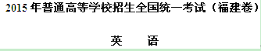
本试卷分为四个部分，共12页。时量120分钟。满分150分
第Ⅰ卷
第一部分 听力(共两节，满分30分)
回答听力部分时，请先将答案标在试卷上。听力部分结束前，你将有两分钟的时间将你的答案转涂到客观题答题卡上。
第一节 (共5小题；每小题1.5分，满分7.5分)
听下面5段对话。每段对话后有一个小题，从题中所给的A、B、C三个选项中选出最佳选项，并标在试卷的相应位置。听完每段对话后；你都有10秒钟的时间来回答有关小题和阅读下一小题。每段对话仅读一遍。
例：How much is the shirt?
A．￡l9.15． B．￡9.15． C．￡9.18．
答案是C。
1. What time is it now?
A. 9:10. B. 9:50. C. 10:00.
2. What does the woman think of the weather?
A. It's nice. B. It's warm. C. It's cold.
3. What will the man do?
A. Attend a meeting. B. Give a lecture. C. Leave his office.
4. What is the woman's opinion about the course?
A. Too hard. B. Worth taking. C. Very easy.
5. What does the woman want the man to do?
A. Speak louder. B. Apologize to her. C. Turn off the radio.
第二节(共15小题；每小题1. 5分，满分22.5分)
听下面5段对话。每段对话后有几个小题，从题中所给的A、B、C三个选项中选出最佳选项，并标在试卷的相应位置。听每段对话前，你将有时间阅读各个小题，每小题5秒钟；听完后，各小题给出5秒钟的作答时间。每段对话读两遍。
听第6段材料，回答第6、7题。
6. How long did Michael stay in China?
A. Five days. B. One week. C. Two weeks.
7. Where did Michael go last year?
A. Russia. B. Norway. C. India.
听第7段材料，回答第8、9题。
8. What food does Sally like?
A. Chicken B. Fish C. Eggs
9. What air the speakers going to do?
A. Cook dinner. B. Go shopping. C. Order dishes.
听第8段材料，回答第10至12题。
10. Where are the speakers?
A. In a hospital. B. In the office. C. At home.
11. When is the report due?
A. Thursday. B. Friday. C. Next Monday.
12. What does George suggest Stephanie do with the report?
A. Improve it. B. Hand it in later. C. Leave it with him.
听第9段材料，回答第13至16题。
13. What is the probable relationship between the speakers?
A. Salesperson and customer. B. Homeowner and cleaner. C. Husband and wife.
14. What kind of department do the speakers prefer?
A. One with two bedrooms. B. One without furniture C. One near a market.
15. How much rent should one pay for the one-bedroom apartment?
A. $350. B. $400. C. $415.
16. Where is the apartment the speakers would like to see?
A. On Lake Street. B. On Market Street. C. On South Street,
听第10段材料，回答第17至20题。
17. What percentage of the world's tea exports go to Britain?
A. Almost 15%. B. About 30%. C. Over 40%.
18. Why do tea tasters taste tea with milk?
A. Most British people drink tea that way.
B. Tea tastes much better with milk.
C. Tea with milk is healthy.
19. Who suggests a price for each tea?
A. Tea tasters. B. Tea exporters. C. Tea companies.
20. What is the speaker talking about?
A. The life of tea tasters. B. Afternoon tea in Britain. C. The London Tea Trade Centre.
第二部分 英语知识运用（共两节，满分45分）
- 单项填空（共15小题；每小题1分，满分15分）
从A、B、C、D四个选项中，选出可以填入空白处的最佳选项，并在答题卡上将该项涂黑。
例: It is generally considered unwise to give a child ______ he or she wants.
A. however B. whatever C. whichever D. whenever
答案是B
21.The research group produced two reports based on the survey, but contained any useful suggestions.
A. all B. none C. either D. Neither
【答案】D
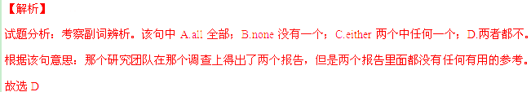考点：考查副词辨析。
22._______A common memory they all have their school days is the school uniform.
A. of B. on C. to D. With
【答案】A
【解析】
试题分析：考察介词辨析。A.of表示关于，表示从属关系；B.on表示在…之上；C.to表示对于；D.with表示和…在一起。该句意思为：他们共有的关于他们学校的记忆是校服。故选A
考点：考查介词辨析。
23.It was________of Michael to inform us of his delay in case we got worried.
A. careless B. considerate C. patient D. Generous
【答案】B
【解析】
试题分析：考查形容词辨析A.careless不小心的；B.considerate体贴的；C.Patient有耐心的；D.generous慷慨的。该句意思为：麦克真是体贴，他通知我们他会迟点来以防我们着急。故选B
考点：考查形容词辨析。
24.The failure was a big to him, but he wasn't discouraged and soon got as enthusiastic as ever.
A. blow B. issue C. excuse D. Factor
【答案】A
【解析】
试题分析：考查名词辨析A.blow打击;B.issue问题;C.excuse借口;D.factor要素。该句意思为：这个失败对他来说是一个打击，但是他没有泄气，很快振作恢复了原来的热情。故选A
考点：考查名词辨析。
25.It is said that body language 55 per cent of a first impression w-hile what you say just 7 per cent.
A. lies in B. accounts for C. consists of D. goes with
【答案】B
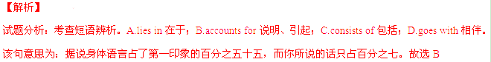考点：考查短语辨析
26.To my delight, I from hundreds of applicants to attend the opening ceremony.
A. was chosen B. was being chosen C. would choose D. had chosen
【答案】A
【解析】
试题分析：考查时态和语态。根据句意：让我高兴的是，我从成百上千的参加者中被选中参加开幕式。可以知道这里应该是被动语态，又因为被选中是过去发生的事情，这里只是对过去发生的事情的一般描述，故用一般过去式，故选A
考点：考查时态和语态辨析。
27.—Sorry, Mum! I failed the job interview again.
—Oh, it's too bad. You have made full preparations.
- must B. can C. would D. Should
【答案】D.
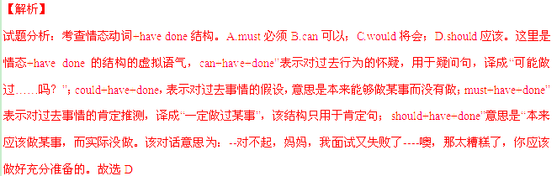考点：考查考查情态动词+have done结构
28. more about Chinese culture, Jack has decided to take Chinese folk music as an elective course.
A. Learn B. Learned C. To learn D. To be learning
【答案】C
【解析】
试题分析：考查非谓语动词。这里是动词不定式形式的非谓语动词做目的状语。该句意思为：为了更多了解到中国文化，杰克决定选择中国传统音乐作为选修课。故选C
考点：考查考查非谓语动词。
29—1 wonder Mary has kept her figure after all these years.
—By working out every day.
- where B. how C. why D. If
【答案】B
【解析】
试题分析：考查宾语从句。句中I是主语，wonder是谓语，how引导的宾语从句在整个句子中做宾语。连接副词How是宾语从句中的方式状语。句子是用表示方式的介词by回答的，所以是针对方式题提问的，故用how。根据句意---我好奇玛丽在这些年是怎么保持着身材的。--通过每天锻炼。故选C
考点：考查宾语从句
30.—Where is Peter? I can't find him anywhere.
—He went to the library after breakfast and his essay there ever since.
- wrote B. had written C. has been writing D. is writing
【答案】C
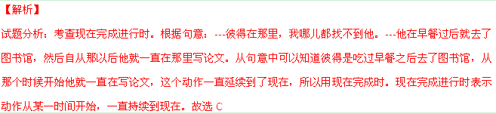考点：考查现在完成进行时
31. the students came from different countries, they got along quite well in the summer camp.
A. While B. Unless C. Since D. Until
【答案】A
【解析】
试题分析：考查连词辨析。这里是一个while引导的让步状语从句。A.while尽管（引导让步状语从句）；B.unless除非（通常用于条件状语从句）；C.since自从（引导时间状语从句）；D.until直到…才…（通常用在时间状语从句中）。结合句意：尽管学生都来自不同的国家，他们在夏令营里面都相处得很好。故选A
考点：考查连词辨析
32.Human life is regarded as part of nature and, as such, the only way for us to survive is to live_________nature.
A. in view of B. in need of C.in touch with D. in harmony with
【答案】D
【解析】
试题分析：考查短语辨析A.in view of在…眼里；B.in need of需要；;C.in touch with和…接触； D. In harmony with与…和谐相处。这四个短语后面都应该接名词，该句意思为：人的生活是自然的一部分，因此，我们生存下来的唯一的方法就是与自然和谐相处。根据句意，故选D
考点：考查短语辨析
33.In recent years an English word "infosphere" has appeared, _______the sense of “information” and " atmosphere".
A. combine B. combined C. combing D. being combined
【答案】C
【解析】
试题分析：考查非谓语动词。非谓语动词主要有动词不定式、现在分词和过去分词形式。其中现在分词表示主动的关系，而过去分词通常表示被动的关系。根据该句意思：最近几年，一个叫做infosphere的英语单词出现了，结合了“信息”和“气氛”这两个单词。这里的结合与前面新出现的单词的关系是主动的，所以故选C
考点：考查非谓语动词
34.China Today attracts a worldwide readership,_______ shows that more and more people all over the world want to learn about China.
A. who B. whom C. that D. Which
【答案】D
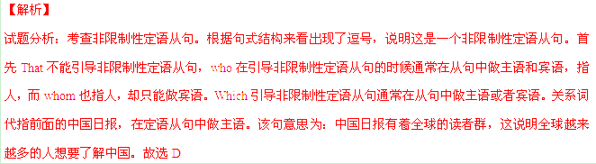考点：考查非限制性定语从句
35.—Hi, Dr Brown! I'm a little early. Should I wait outside?
—No. .
A. That's right B. My pleasure C. Come on in D. Take it easy
【答案】C
【解析】
试题分析：考查句子衔接。A. That's right对了；B. My pleasure 我的荣幸；C. Come on in 请进；D. Take it easy放松。该句意思为：--你好，布朗医生，我来的有点早，我应该在外面等么？---不，进来吧。结合语境来看，布朗医生并不觉得病人来得早，所以让病人进来了。故选C
考点：考查句子衔接
第二节 完形填空（共20小题；每小题1.5分，满分30分）
阅读下面短文，从短文后各题所给的四个选项（A、B、C、和D）中，选出可以填入空白处的最佳选项，并在答题卡上将该项涂黑。
One of the easiest things in the world is to become a fault-finder. However, life can be 36 when you are not busy finding fault with it.
Several years ago I 37 a letter from seventeen-year-old Kerry, who described herself as a world-class fault-finder, almost always 38 by things. People were always doing things that annoyed her, and 39 was ever good enough. She was highly self-critical and also found fault with her friends. She became a really 40 person.
Unfortunately, it took a horrible accident to change her 41 Her best friend was seriously hurt in a car crash. What made it almost 42 to deal with was that the day before the 43 , Kerry had visited her friend and had spent the whole time criticizing her 44 of boyfriends, the way she was living, the way she related to her mother, and various other things she felt she needed to 45 It wasn't until her friend was badly hurt that Kerry became 46 her habit of finding fault. Very quickly, she learned to appreciate life rather than to 47 everything so harshly ( 刻薄) . She was able to transfer her new wisdom to other parts of her 48 as well.
Perhaps most of us aren't as extreme at fault-finding, 49 when we're honest, we can be sharply 50 of the world. I'm not suggesting you 51 problems, or that you pretend things are 52 than they are, but simply that you learn to allow things to be as they are— 53 most of the time, and especially when it's not a really big 54 .
Train yourself to "bite your tongue" , and with a little 55, you'll get really good at letting things go. And when you do, you'll get back your enthusiasm and love for life.
36. | A. | lonely | B. | great | C. | quiet | D. | uneasy
37. | A. | received | B. | answered | C. | expected | D. | rejected
38. | A. | threatened | B. | interrupted | C. | bothered | I). | spoiled
39. | A. | anything | B. | everything | C. | something | D. | nothing
40. | A. | caring | B. | boring | C. | interesting | D. | surprising
41. | A. | attitude | B. | plan | C. | measure | D. | explanation
42. | A. | urgent | B. | unnecessary | C. | certain | D. | impossible
43. | A. | occasion | B. | event | C. | accident | D. | adventure
44. | A. | memory | B. | notice | C. | evidence | D. | choice
45. | A. | hear | B. | contribute | C. | express | D. | admit
46. | A. | aware of | B. | afraid of | C. | curious about | D. | confused about
47. | A. | discuss | B. | realize | C. | judge | D. | settle
48. | A. | family | B. | life | C. | career | D. | education
49. | A. | so | B. | or | C. | but | D. | for
50. | A. | proud | B. | sure | C. | hopeful | D. | critical
51. | A. | face | B. | create | C. | solve | D. | ignore
52. | A. | rarer | B. | better | C. | stranger | D. | worse
53. | A. | at least | B. | at last | C. | by far | D. | so far
54. | A. | task | B. | deal | C. | result | D. | duty
55. | A. | practice | B. | speech | C. | rest | D | pity
【答案】
36.B
37.A
38.C
39.D
40.B
41.A
42.D
43.C
44.D
45.C
46.A
47.C
48.B
49.C
50.D
51.D
52.B
53.A
54.B
55.A
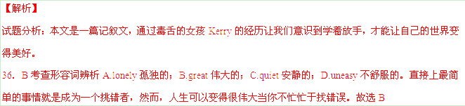 37．A考查动词辨析A.received接受；B.answered回答；C.expected期望；D.rejected排斥。几年以前，我收到一个来自17岁女孩kerry的信。故选A
38．C考查动词辨析A.threatened威胁；B.interrupted打扰；C.bothered麻烦；D.spoiled娇惯。这个叫做Kerry的女孩说自己是一个世界级的找错者，她总是被各种事情困扰着。故选C
39．D考查不定代词辨析A.anything任何事；B.everything每一件事；C.something某事；D.nothing没有事。人们总是做着那些惹她恼怒的事情，没有一件事是好的，故选D
40．B考查形容词辨析A.caring关心的；B.boring糟糕的；C.interesting有趣的；D.surprising令人惊奇的。 她具有高度的自我批评精神，她也会对自己的朋友挑毛病。她成为了一个非常糟糕的人。故选B
41．A考查名词辨析A.attitude态度；B.plan计划；C.measure措施；D.explanation解释。不幸的，一场恐怖的事故发生改变了她的态度。故选A
42．D考查形容词辨析A.urgent 经济的；B.unnecessary不必要的；C.certain确定的；D.impossible不可能的。她最好的朋友在一场车祸中受伤很严重，让事情处理起来变得不可能的事情是，发生事故的前一天Kerry拜访了她的朋友…故选D
43．C考查名词辨析A.occasion场合；B.event事项；C.accident事故；D.adventure冒险。她最好的朋友在一场车祸中受伤很严重，让事情处理起来变得不可能的事情是，发生事故的前一天，Kerry拜访了她的朋友，在这期间全程批评了她选择男朋友的眼光…故选C
44．D考查名词辨析A.memory记忆；B.notice注意；C.evidence证据；D.choice选择。发生事故的前一天，Kerry拜访了她的朋友，在这期间全程批评了她选择男朋友的眼光、她生活的方式、她与母亲联络时候的方式，还有各种其他她认为她需要表达的…故选D
45．C考查动词辨析A.hear听；B.contribute贡献；C.express表达；D.admit承认、许可。发生事故的前一天，Kerry拜访了她的朋友，在这期间全程批评了她选择男朋友的眼光、她生活的方式、她与母亲联络时候的方式，还有各种其他她认为她需要表达的。故选C
46．A考查短语辨析A.aware of注意； B.afraid of担心；C.curious about对…好奇；D.confused about对…迷惑。直到他的朋友受了重伤，Kerry才注意到她挑毛病的习惯。故选A
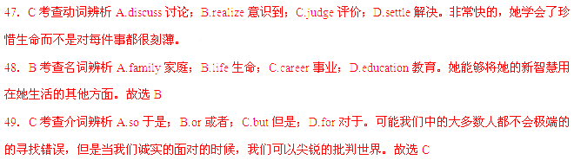 50．D考查形容词辨析A.proud骄傲的；B.sure确定的；C.hopeful有希望的；D.critical批判的。可能我们中的大多数都不会极端的的寻找错误，但是当我们诚实的面对的时候，我们可以尖锐的批判这个世界。故选D
51．D考查动词辨析A.face面对；B.create创造；C.solve解决；D.ignore忽略。我并不是在建议你无视问题。故选D
52．B考查形容词比较级辨析A.rarer更稀罕的；B.better更好的；C.stranger更奇怪的；D.worse更坏的。我也不是在建议你假装事物比它们自身更好。故选B
53．A考查短语辨析A.at least至少；B.at last最后；C.by far到现在为止；D.so far迄今为止。至少在大多数时间里，你学着容忍事物的原态。故选A
54．B考查名词辨析A.task任务；B.deal处理、交易；C.result计划；D.duty责任。尤其是当这不是一个特别大的事情。故选B
55．A考查名词辨析A.practice实践；B.speech演讲；C.rest休息；D.pity遗憾。训练你自己忍着不说那些刻薄的话，小小的实践一下，你会变得很擅长放手。故选A
考点：记叙文阅读。
第三部分阅 读理解(共20小题；每小题2分，满分40分)
阅读下列短文，从每题所给的四个选项(A、B、C和D)中，选出最佳选项，并在答
题卡上将该项涂黑。
A

Food festivals around the world
Stilton Cheese Rolling
May Day is a traditional day for celebrations, but the 2,000 English villagers of Stilton must be the only people in the world who include these rolling in their annual plans. Teams of four,dressed in a variety of strange and funny clothes , roll a complete cheese along a 50-metre course. On the way, they must not kick or throw their cheese, or go into their competitors' lane. Competition is fierce and the chief prize is a complete Stilton cheese weighing about four kilos (disappointingly, but understandably the cheeses used in the race are wooden ones). All the
competitors arc served with beer or port wine, the traditional accompaniment for Stilton cheese.
Fiery Foods Festival—The Hottest Festival on Earth
Every year more than 10,000 people head for the city of Albuquerque, New Mexico. They come from as far away as Australia, the Caribbean and China, but they all share a common addiction—food that is not just spicy ,but hot enough to make your mouth burn, your head spin and your eyes water. Their destination is the Fiery Eood and BBQ Festival which is held over a period of three clays every March. You might like to try a chocolate-covered habanero pepper—officially the hottest pepper in the world—or any one of the thousands of products that are on show. But one thing's for sure—if you don't like the feeling of a burning tongue, this festival isn't for you!
La Tomatina—The World's Biggest Food Fight
On the last Wednesday of every August, the Spanish town of Bunol hosts Ea Tomatina—the world's largest food fight. A week-long celebration leads up to an exciting tomato battle as the highlight of the week's events. The early morning sees the arrival of large trucks with tomatoes—official fight-starters get things going by casting tomatoes at the
crowd.
The battle lasts little more than half an hour, in which time around 50,000 kilograms of tomatoes have been thrown at anyone or anything that moves, runs, or fights back. Then everyone heads down to the river to make friends again—and for a much-needed wash!
56. In the Stilton cheese rolling competition, competitors on each team must .
A. wear various formal clothes
B. roll a wooden cheese in their own lane
C. kick or throw their cheese
D. use a real cheese weighing about four kilos
57.Where is the Fiery Food and BBQ Festival held?
A. In New Mexico. B. In the Caribbean. C. In Australia. D. In China.
58.The celebration of La Tomatina lasts .
A. three days B. seven days C. less than three days D. more than seven days
59.Which of the following is TRUE according to the passage?
A. The chief prize for the Stilton cheese rolling competition is beer or port wine.
B.More than 10,000 Chinese take pail in the Fiery Food and BBQ Festival.
C. Thousands of spicy foods are on show in the Fiery Food and BBQ Festival.
D. An exciting tomato battle takes place at the beginning of La Tomatina.
【答案】
56.B
57.A
58.B
59.C
 57.A细节理解题。根据第二段第一句Every year more than 10,000 people head for the city of Albuquerque, New Mexico.可以知道这是在新墨西哥发生的事情，从段落中第三句Their destination is the Fiery Eood and BBQ Festival可以知道人们到新墨西哥是为了参加Fiery food festival。故选A
58.B细节理解题。根据文章第三段第二句A week-long celebration leads up to an exciting tomato battle as the highlight of the week's events.可以知道，西红柿大战这个西班牙的节日的持续时间是一周，故选B
59.C细节理解题。根据文章第二段倒数第二个破折号后面的文字or any one of the thousands of products that are on show.可以知道你可以任意品尝展出的上千种的食物。故选C
考点：说明文阅读。

B
Papa, as a son of a dirt-poor farmer, left school early and went to work in a factory, for education was for the rich then. So, the world became his school. With great interest, he read everything he could lay his hands on, listened to the town elders and learned about the world beyond his tiny hometown. "There's so much to learn," he'd say. "Though we're born stupid, only the stupid remain that way. " He was determined that none of his children would be denied an education.
Thus, Papa insisted that we learn at least one new thing each day. Though, as children, we thought this was crazy, it would never have occurred to us to deny Papa a request. And dinner time seemed perfect for sharing what we had learned. We would talk about the news of the day; no matter how insignificant, it was never taken lightly. Papa would listen carefully and was ready with some comment, always to the point.
Then came the moment—the time to share the day's new learning.
Papa, at the head of the table, would push back his chair and pour a glass of red wine, ready to listen.
"Felice," he'd say, "tell me what you learned today. "
"I learned that the population of Nepal is .... "
Silence.
Papa was thinking about what was said, as if the salvation of the world would depend upon it. "The population of Nepal. Hmm. Well . . . . " he'd say. "Get the map; let's see where Nepal is. " And the whole family
went on a search for Nepal.
This same experience was repeated until each family member had a turn. Dinner ended only after we had a clear understanding of at least half a dozen such facts.
As children, we thought very little about these educational wonders. Our family, however, was growing together, sharing experiences and participating in one another's education. And by looking at us, listening to us, respecting our input, affirming our value, giving us a sense of dignity, Papa was unquestionably our most influential teacher.
Later during my training as a future teacher /1 studied with some of the most famous educators. They were imparting what Papa had known all along—the value of continual learning. His technique has served me well all my life. Not a single day has been wasted, though I can never tell when knowing the population of Nepal might prove useful.
60.What do we know from the first paragraph?
A. The author's father was born in a worker's family.
B. Those born stupid could not change their life.
C. The town elders wanted to learn about the world.
D. The poor could hardly afford school education.
61.The underlined word "it" in the second paragraph refers to "
A. one new thing B. a request C. the news D. some comment
62.It can be learned from the passage that the author .
A. enjoyed talking about news
B. knew very well about Nepal
C. felt regret about those wasted days
D . appreciated his father's educational technique
63What is the greatest value of "dinner time" to the author?
A. Continual learning. B. Showing talents.
C. Family get-together. D. Winning Papa's approval.
64.The author's father can be best described as .
A. an educator expert at training future teachers
B. a parent insistent on his children's education
C. a participant willing to share his knowledge
D. a teacher strict about everything his students did
【答案】
60.D
61.C
62.D
63.A
64.B
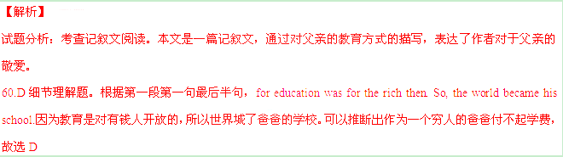 61.C分析推断题。这里的it代指的是news，代指的是前面的主语。根据该词附近的语境可以知道我们会谈论一天的新闻，不论重要与否，都不是可以等闲视之的。故选C
62.D细节理解题。根据最后一段前两句Later during my training as a future teacher studied with some of the most famous educators. They were imparting what Papa had known all along：在我成为未来教师的实习中，我和一些很有名的教育者一同学习，他们传授着父亲所知道的——持续教育的意义。故选D
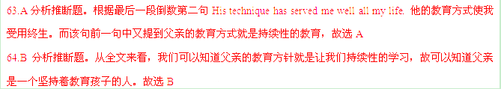考点：记叙文阅读。

C

SIGN YOUR CHILD UP FOR "FLY TO THE MOON CLUB"
AND ENJOY A FREE * FLIGHT TO ANY DESTINATION IN ASIA!
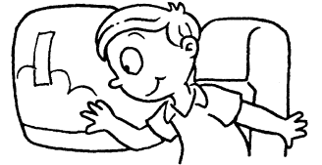
With a registration fee of just $50 per child,
children under the age of 12
can join Eagle Airways'
FLY TO THE MOON CLUB as members.
They can then enjoy the same benefits
onboard Eagle Airways' newest Boeing-797
to any destination in the world!
BENEFITS YOU CAN'T MISS!
• A free * flight to any destination in Asia
• 30% off any course at Tanya Language School
• 20% off any purchase made at Ruby Bookstore
• A free notebook with every purchase above $50 at Starlight Stationery
• A free bowl of dessert for a family of four at Don's Diners
dinner ordered
• A birthday gift on your child's birthday
• A free album containing pictures taken during the journey
All bookings made before 12 September will receive free travel insurance for
the entire family! ** Insurance is issued by Live Life Insurance Group.
10% OFF ALL BOOKINGS
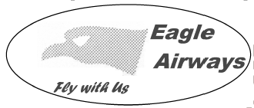
for departures from 5 to 11 September
* Child must be accompanied by two
paying adults.
** Terms and conditions apply.

65.One of the benefits mentioned in, the advertisement is .
A.a free flight to any destination in the world
B.30% off any book purchased at Ruby Bookstore
C.a free bowl of dessert at any restaurant at the airport
D.a discount on any course at Tanya Language School
66.Which of the following bookings may receive the most benefits?

Booking date | Departure date
September 13 | September 18

B．
Booking date | Departure date
September 2 | September 12
C.
Booking date | Departure date
August 15 | September 4

D.
Booking date | Departure date
August 16 | September 8

67. Which of the following is TRUE according to the advertisement?
A.You need to pay$50 to sign up a child for the club.
B.Club members enjoy free travel insurance for any flight.
C.The advertisement is intended for students of all ages.
D.Any child must be accompanied by at least one paying adult.
【答案】
65.D
66.D
67.A
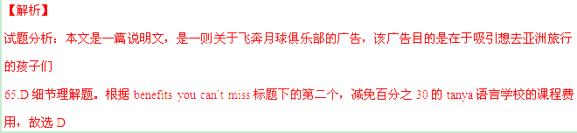 66.D细节理解题。根据图中偏下部的内容All bookings made before 12 September will receive free travel insurance for the entire family! 可以知道在9月12日之前预定可以得到免费保险，10% OFF ALL BOOKINGS for departures from 5 to 11 September预定日期在2015年5到11号离开的可以享受百分之10的减免。故选D
67.A细节理解题。根据主标题下面第一句With a registration fee of just $50 per child,
children under the age of 12 can join Eagle Airways'FLY TO THE MOON CLUB as members.
可以知道一个12岁以下的孩只要50美元就可以加入俱乐部。故选A
考点：说明文阅读。
D
Life can be so wonderful, full of adventure and joy. It can also be full of challenges, setbacks and heartbreaks. Whatever our circumstances, we generally still have dreams, hopes and desires—that little something more we want for ourselves and our loved ones. Yet knowing we can have more can also create a problem, because when we go to change the way we do things, up come the old patterns and pitfalls that stopped us from seeking what we wanted in the first place.
This tension between what we feel we can have and "what were seemingly able to have is the niggling suffering, the anxiety we feel. This is where we usually think it's easier to just give up. But we're never meant to let go of the part of us that knows we can have more. The intelligence behind that knowing is us—the real us. It's the part that believes in life and its possibilities. If you drop that, you begin to feel a little "dead" inside because you're dropping "you".
So, if we have this capability but somehow life seems to keep us stuck, how do we break these patterns?
Decide on a new course and make one decision at a time. This is good advice for a new adventure or just getting through today's challenges.
While, deep down, we know we can do it, our mind—or the minds of those close to us—usually says we can't.
That isn't a reason to stop, it's just the mind, that little man or woman on your shoulder, trying to talk you out of something again. It has done it many times before. It's all about starting simple and doing it now.
Decide and act before overthinking. When you do this you may feel a little, or large, release from the jail of your mind and you'll be on your way.
68.It can be inferred from the first two paragraphs that we should .
A.slow down and live a simple life
B.be careful when we choose to change
C.stick to our dreams under any circumstances
D.be content with what we already have
69.What is the key to breaking the old patterns?
A. To focus on every detail. B. To decide and take immediate action.
C. To listen to those close to us. D. To think twice before we act.
70.Which of the following best explains the underlined part in the last paragraph?
A. Escape from your punishment B. Realization of your dreams.
C. Freedom from your tension. D. Reduction of your expectations.
71.What does the author intend to tell us?
A.It's easier than we think to get what we want.
B. It's important to learn to accept sufferings in life.
C. It's impractical to change our way of thinking.
D. It's harder than we expect to follow a new course.
【答案】
68.C
69.B
70.C
71.A
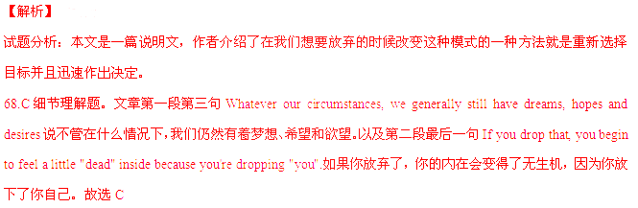 69.B细节理解题。根据倒数第三段第一句Decide on a new course and make one decision at a time.可以知道为了打破旧格局需要决定一个新目标并且立刻做出决定。故选B
70.C分析推断题。根据划线句子可知其本意是逃出你内心的牢笼。结合上文中在过多思考之前快速决定和行动可以推测这个划线句子是指要从过多考虑的焦虑中解放自己。故选C
71.A分析推断题。从全文来看，作者主要是想要强调果断的行动而不是空想来实现自己的梦想和欲望，故选A.比起想要成功，行动更加容易。
考点：说明文阅读。

E
Group exercise is one of the most effective ways to improve physical fitness and sustain a healthy lifestyle.Group exercise is challenging, yet fun and empowering! Of course everyone knows that exercise is good for the body.However, studies have shown that when exercise is performed in groups, it's not only great for improving physical health but for psychological health. It's an opportunity to be social, release endorphins , and improve your strength. Additionally, group exercise creates a community feel and the shared common goal motivates participants to work hard. The instrumental support of taking on a fitness journey with others proves more effective than going to the gym alone.
Another beneficial aspect of group exercise is the informational support participants receive from the instructor.Many people fear the gym because they feel lost and don't want to embarrass themselves. If you feel you can relate, then group training is an even better option for you. It's a great opportunity to learn more about fitness through the clear instruction and supervision of a fitness instructor. If you're tired of wandering around the gym wasting time and becoming bored, !you can attend an upbeat group fitness class that'll keep your workout on track. Don't let
fitness frighten you!
If you're serious about wanting to live a healthy lifestyle, it's extremely important to surround yourself with people who'll provide you with the proper emotional support. I wouldn't scold anyone for deciding to party on weekends and in turn I wouldn't expect anyone to give offence to me for focusing on my health. Surround yourself with people who uplift, encourage and understand you! Make fitness even more fun by trying something new or any group fitness class, with a friend. Plan to go for a jog together. Then try a fun healthy restaurant or fresh juice bar! Fitness can be both fun and social!
Surrounding yourself with people who'll provide you with respect support can be very beneficial while working towards reaching health and fitness goals. First, decide to do it for yourself and work towards staying positive. Then make sure the people you surround yourself with are supportive. Don't let negativity ruin your motivation.
72. The first paragraph focuses on .
A. the greatest challenge of group exercise
B. the most effective way to improve physical fitness
C. the contribution of group exercise to psychological health
D. the shared common goal in performing exercise in groups
73. The underlined word "upbeat" in the second paragraph probably means "
A. cheerful B. average C. serious D. temporal
74. When it comes to emotional support, the author thinks it necessary
A. to sustain a colorful lifestyle
B. to party on weekends with positive people
C. to try a fun healthy restaurant regularly
D. to surround yourself with supportive people
75. What would be the best title for the passage?
A. Seeking Support B. Supporting Health
C. Improving Your Strength D. Building Up Fitness
【答案】
72.C
73.A
74.D
75.B
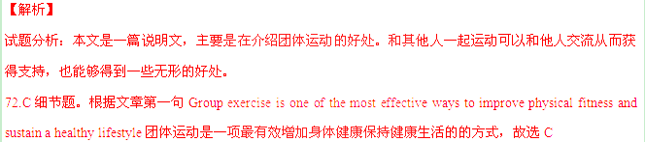 73.A分析推断题。从划线短语所在句子你可以参加一个upbeat的集体健康课，那将会使得你正确的锻炼自己。前半句if you're tired of wandering around the gym wasting time and becoming bored, 是一个if引导的条件句，意思是假如你对于在健身房游荡感到心烦并且觉得这很浪费时间。所以这个单词应该是与浪费时间和让你心烦相反的意思，故选A
74.D细节理解题。根据最后一段第一句Surrounding yourself with people who'll provide you with respect support can be very beneficial while working towards reaching health and fitness goals.在以健康为目标锻炼的时候和那些你能够给你尊敬和支持的人们在一起是很有益处的，故选D
75.B分析推断题。文章的主要内容是在说团体运动的好处，团体运动包含的好处主要是因为大家在一起运动，不仅生理上会有一些好处，而且团内其他成员会给你支持，教练也会给你们一些信息上的支持，故选B
考点：说明文阅读。

第Ⅱ卷
第四部分 写作 (共两节，满分35分)
第一节 短文填词(共10小题；每小题1分，满分10分)
Sometimes we have disagreements with people. When this (76) h , the important thing is to try not to let a calm discussion turn into a heated argument. Here (77 ) my tips for you.
The (78) f thing I would say is that the way you begin the conversation is very important.
Imagine you are a student and you share a flat (79) another student who you think isn't doing her share of the housework. If you say, "Look, you never do your share of the housework. (80) are you going to do about it?", the discussion will very soon turn into an argument. It's much more (81)______ (有帮助)to say something like, "I think we had (82) b _____ have another look about how we divide up the housework. Maybe there is a better way of dealing with it. "
My second piece of (83) a is simple. If you're the person who is in the wrong, just admit it! This is the easiest and best way to avoid an argument. Just make an (84) (道歉)， and move on. The other person will have more respect for you (85) the future if you do that.
【答案】
76.happens
77.are
78.first
79.with
80.what
81.helpful/beneficial
82.better
83.advice
84.apology
85.in
【解析】
试题分析：该类题目主要是考查考生的单词水平和语法水平，注意时态的变换和动词短语搭配。
76.happens考察选词填空。Happen意思是发生，前面的this代指前一句中的和别人发生分歧。因为该句是一般现在时，而且主语是this所以谓语动词应该用第三人称单数。该句意思为：当这种情况发生了，重要的事情就是不要让一场平静的讨论变成热力的争论。
77.are考察固定结构。固定结构Here are……表示这里有……，该句意思为：这里是一些给你的小建议。
78.first考察形容词。因为该空前有冠词the该空后有名词thing，所以中间只能是形容词或者副词。因为该句是第二段的第一句，并且后文中有表示层次的词second，所以可以推断这里应该是first。
79.with考察固定短语。固定短语Share with意思是和…分享。该句意思为：想象你是一个学生并且和其他一个你认为她不愿意做她那份家务的学生合租一间公寓。
80.what考察特殊疑问句引导词，what引导的是一个特殊疑问句，表示什么。该句意思为：看看，你从来不做家务，你究竟打算怎么做？
81.helpful/beneficial考察形容词。根据所给提示有帮助的，helpfu或者beneficial都有有利于的意思。该句意思为：这样说就比较有帮助（不破坏关系）……
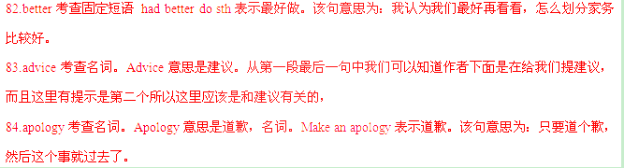 85.in考查固定短语。固定短语In the future表示在未来。该句意思为：如果你那样做，在未来，一些人会对你更加尊敬。
考点：考察固定结构等。
第二节 书面表达(满分25分）
86.请阅读下面图画，按要求用英语写一篇词数为120左右的短文。
内容包括：
1. 描述画面；
2. 概述其含义；
3. 谈谈个人感想。
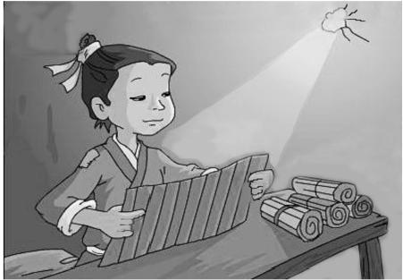
凿壁偷光

注意：
1. 短文开头已给出,不计入总词数；
2. 可以适当增加细节,以使行文连贯；
3. 短文中不能出现与本人相关的信息；
参考词汇：凿，钻：bore
In the picture,
【答案】
In the picture ,we can see a boy in worn clothes,sitting at a shabby wooden table with a pile of books on it.A weak ray of light came in through a small hole in the wall and he was absorbed in his reading.
This is a well-known story from ancient Chinese idiom.The boy, being poor ,couldn’t afford even a candle,so he bored a hole in the wall to “steal” light from his neighbour ‘s house to read at night.The moral of the story is spare no effort to accquire knowledge and never get discouraged easily no matter how difficult the situation may be
Of course, things are totally different today It is not the story itself but what is reflected in the story that counts.Hard work pays off.We should take pains to improve ourselves through learning and get perpared for the future.
【解析】
试题分析：本题为看图写作，主题是古时候的一则成语“凿壁偷光”。注意条理要清晰，逻辑顺序和结构要恰当，同时要尽量保持简洁精干的内容，不拖泥带水。要注意题中所给的信息，不可偏题，应用文写作对于文章内容的要求是要达到写作目的。尽量保持卷面整洁，字体美观，注意行文的连贯性。
【亮点分析】
文章第一段描述图片，第一句中用到了动词ing形式的非谓语动词做伴随状语和with 的复合结构In the picture ,we can see a boy in worn clothes,sitting at a shabby wooden table with a pile of books on it.图中我们可以看见一个男孩穿着破旧的衣服坐在一个堆满书的桌子旁边。A weak ray of light came in through a small hole in the wall and he was absorbed in his reading.一丝微弱的光亮从墙上的一个小洞穿过，他沉静在自己的阅读中。第二段第一句开始说这个图片的主题。This is a well-known story from ancient Chinese idiom.这是一个众人周知的中国古代成语。第二句也是用了一个分词结构表示伴随状语The boy, being poor ,couldn’t afford even a candle,so he bored a hole in the wall to “steal” light from his neighbour ‘s house to read at night.这个贫穷的男孩甚至不能够买得起一根蜡烛，于是他把墙凿了一个洞，从他邻居那里偷了一些光在夜晚阅读。第二段最后一句用了一个no matter引导的让步状语从句。The moral of the story is spare no effort to accquire knowledge and never get discouraged easily no matter how difficult the situation may be.故事的精神是要不遗余力的获取知识，并且不管有多么困难的情况从不轻易气馁。第三段结束Of course, things are totally different today .当然，现在可完全不同了。第二句是一个not… but 结构以及宾语从句It is not the story itself but what is reflected in the story that counts.不是这个故事本身而是这个故事反映出来的东西才是重要的。俗语：Hard work pays off.功夫不负有心人。We should take pains to improve ourselves through learning and get perpared for the future.我们应该带着苦来通过学习来改进自己并且为未来做准备。
考点：看图说话写作。

