第一部分：英语知识运用（共四节，满分55分）
第一节 语音知识（共5小题；每小题1分，满分5分）
从每小题的A、B、C、D四个选项中，找出其划线部分与所给单词的划线部分读音相同的选项，并在答题卡上将该选项涂黑。
1. stomach
A. technology B. exchange C. chair D. church
2. uncle
A. concert B. strange C. blanket D. autumn
3. exact
A. excellent B. example C. exercise D. expensive
4. table
A. cottage B. basket C. wake D. family
5. double
A. soul B. group C. pronounce D. couple
【答案】
1.A
2.C
3.B
4.C
5.D
 5.double和couple里面的字母ou都是读/ ʌ /，soul里面的字母ou读/əʊ/，group里面的字母ou读/u：/，pronounce里面的字母ou读/au/,选D。
【考点定位】考查单词辨音
第二节 情景对话（共5小题；每小题1分，满分5分）
根据对话情境和内容，从对话后所给的选项中选出能填入每一空白处的最佳选项，并在答题卡上将该选项涂黑。选项中有两个为多余选项。
Doctor: Good morning, Sir. 6
Johnson :Yes, doctor. I'm always tired but when I go to bed I can't sleep.
Doctor: 7
Johnson : Since I started my new job two months ago.
Doctor : What is your job ?
Johnson : I’m in advertising. 8
Doctor : It depends. How many hours do you work?
Johnson: About 80 hours a week
Doctor: 9 . Do you often take exercise?
Johnson: Not very often. 10 .
Doctor; Well, you do need to find some time. Try to work less, or look for a more stress-free job.
A. That's a lot!
B. I like my job.
C. Does it matter?
D. How can I help you?
E. I don't have the time.
F. What time do you usually go to bed?
G.. How long have you had this problem?
【答案】
6.D
7.G
8.C
9.A
10.E
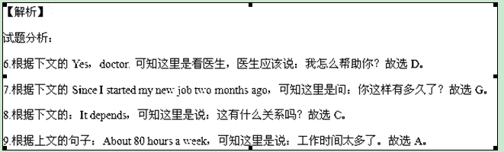
10.根据上句：Not very often，可知这里是：我没有时间（锻炼）。故选E。
【考点定位】考查情景对话。
单项选择
第三节 语法和词汇知识（共15小题；每小题1分，满分15分）
从每小题的A、B、C、D四个选项中，选出可以填入空白处的最佳选项，并在答题卡上将该选项涂黑。
11. ---Let’s go to the New Year’s Eve party, shall we?
---- I guess it will be fun.
A. Forget it! B. No way! C. Why not? D. What for?
【答案】C
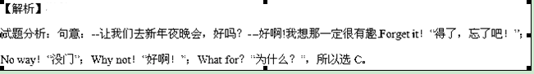【考点定位】考查交际英语
12. The little pupil took his grandma the arm and walked her across the street.
A. on B. by C. in D. at
【答案】B
【解析】
试题分析：句意：这个小学生拉住他奶奶的膀子和她一起穿过街道.take sb by the arm拉住某人的膀子，所以选B。
【考点定位】考查介词
13. To warm himself, the sailor sat in front of the fire rubbing one bare foot against .
A. another B. the other C. other D. either
【答案】B
【解析】
试题分析：句意：为了提醒自己，这个水手坐在火前面一只光脚摩擦另外一只脚。因为人有两只脚，一只是one，另外一只是the other，所以选B.
【考点定位】考查代词
14. more learned a man is, more modest be usually become.
A. The ; the B. A; a C. The ; a D. A; the
【答案】A
【解析】
试题分析：句意：一个人越有学识，他就越可能更谦虚，使用the +比较级+主谓， the +比较级+主谓的句型，所以选A.
【考点定位】考查冠词
15. As the smallest child of his family, Alex is always longing for the time he should be able to be independent.
A. which B. where C. whom D. when
【答案】D
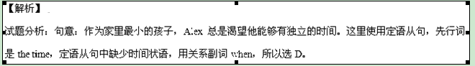【考点定位】考查定语从句
16. —Sir, could I hand in my homework a bit late?
----- __________, since you’ve been unwell these days.
A. You can’t be serious B. I’m afraid not
C. Good idea D. Well, all right
【答案】D
【解析】
试题分析：句意：--老师，我可以迟一些交我的作业吗？--好的，因为你最近一直不舒服。You can’t be serious你一定是开玩笑吧!；I’m afraid not恐怕不行；Good idea好主意；Wll，all right好啊，行。所以选D。
【考点定位】考查交际英语
17. After receiving the Oscar for Best Supporting Actress, Anne Benedict went on all the people who had helped in her career.
A. to thank B. thanking C. having thanked D. to have thanked
【答案】A
【解析】
试题分析：句意：在获得奥斯卡最佳女配角后，Anne Benedict继续感谢所有帮助她演绎生涯的人。go on to do继续做不同的事情，所以选A.
【考点定位】考查不定式
18. Back from his two-year medical service in Africa, Dr. Lee was very happy to see his mother good care of at home.
A. taking B. taken C. take D. be taken
【答案】B
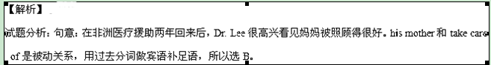【考点定位】考查过去分词
19. Reading her biography, I was lost in admiration for Doris Lessing had achieved in literature.
A. what B. that C. why D. how
【答案】A
【解析】
试题分析：句意：读完了她的自传后，我对Doris Lessing在文学上做出的贡献非常敬佩。介词for后面是宾语从句，从句中缺少宾语，所以选A。
【考点定位】考查宾语从句
20. I believe you will have a wonderful time here you get to know everyone else.
A. though B. as if C. once D. so that
【答案】C
【解析】
试题分析：句意：我相信一旦你了解这里的每个人，你将玩得很愉快。though虽然；as if好像；once一旦；so that为了。所以选C。
【考点定位】考查连词
21. You feel all the training a waste of time, but I’m a hundred percent sure later you’ll be grateful you did it.
A. should B. need C. shall D. may
【答案】D
【解析】
试题分析：句意：你可能觉得所有的训练都是浪费时间，但是我有100%的把握你以后会感激它的。should应该；need需要；shall将会；may（不确定）可能。所以选D。
【考点定位】考查情态动词
22. Mary really hard on his book and thinks he’ll have finished it by Friday.
A. worked B. has been working C. had worked D. has worked
【答案】B
【解析】
试题分析：句意：Marty一直努力写书，我想他到周五为止将已经完成了。用现在完成进行时表示从过去到现在一直进行的动作。所以选B。
【考点定位】考查现在完成进行时
23. Ellen is a fantastic dancer. I wish I as well as her.
A. dance B. will dance C. had danced D. danced
【答案】C
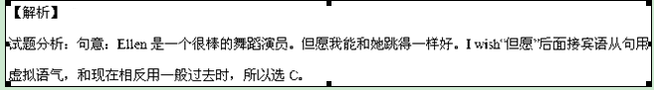【考点定位】考查虚拟语气
24. At college, Barack Obama didn’t know that he the first black president of the United States of America.
A. was to become B. becomes C. is to become D. became
【答案】A
【解析】
试题分析：句意：在大学的时候，奥巴马不知道他将成为美国第一个黑人总统。用过去将来时表示过去某个时间将要发生的事情，所以选A。
【考点定位】考查过去将来时
25. Peter will his post as the head of the travel agency at the end of next month.
A. take up B. put up C. add up D. break up
【答案】A
【解析】
试题分析：句意：Peter在这个月底将从事旅行社负责人的职位。take up拿起，开始从事；put up竖立；搭建；add up加起来；break up结束；分解。所以选A。
【考点定位】考查动词短语
第四节 完形填空（共20小题；每小题1.5分，满分30分）
阅读下面短文， 从短文后各题的A、B、C、D四个选项中，选出适合填入对应空白处的最佳选项，并在答题卡上将该选项涂黑。
Dad had a green comb. He bought it when he married Mum. Every night, he would hand me his 26 and say, “Good girl, help Daddy clean it, OK?”
I was 27 to do it. At age five , this dull task brought me such 28 . I would excitedly turn the tap 29 and brush the comb carefully. Satisfied that I’d done a good job, I would happily return the comb to Dad. He would 30 affectionately at me and place the comb on his wallet.
Two years later, Dad started his own 31 , which wasn’t doing so well. That was when things started to 32 . Dad didn’t come home as early and as much as he used to. Mum and I became 33 with him for placing our family in trouble. With 34 , an uncomfortable silence grew between us.
After my graduation, Dad’s business was getting back on track. On my 28th birthday, Dad came home 35 . As usually I helped him carry his bags into his study. When I turned to leave, he said ,“Hey, would you help me 36 my comb?” I looked at him a while, then 37 the comb and headed to the sink.
It hit me then: why, as a child, 38 Dad clean his comb was such a pleasure. That routine(习惯) meant Dad was home early to 39 the evening with Mum and me. It 40 a happy and loving family.
I passed the clean comb back to Dad. He smiled at me and 41 placed his comb on his wallet. But this time , I noticed something 42 . Dad had aged. He had wrinkles next to his eyes when he smiled, 43 his smile was still as 44 as before, the smile of a father who just wanted a good 45 for his family.
26. A. bag B. wallet C. comb D. brush
27. A. annoyed B. relieved C. ashamed D. pleased
28. A. joy B. sadness C. courage D. pain
29. A. out B. over C. in D. on
30. A. stare B. smile C. shout D. laugh
31. A. family B. business C. task D. journey
32. A. progress B. change C. improve D. form
33. A.satisfied B. delighted C. mad D. strict
34. A. time B. patience C. speed D. ease
35. A. occasionally B. early C. frequently D. rarely
36. A. sharply B. repair C. clean D. keep
37. A. dropped B. took C. handed D. threw
38. A. watching B. letting C. helping D. hearing
39. A. find B. lose C. waste D. spend
40. A. affected B. broke C. meant D. supported
41. A. firmly B. hurriedly C. casually D. carefully
42. A. different B. exciting C. interesting D. urgent
43. A. for B. or C. so D. yet
44. A. convincing B. heartwarming C. cautious D. innocent
45. A. origin B. life C. reputation D. education
【答案】
26. C
27. D
28. A
29. D
30. B
31. B
32. B
33. C
34. A
35. B
36. C
37. B
38. C
39. D
40. C
41. D
42. A
43. D
44. B
45. B
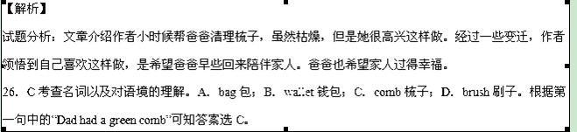 27．D 考查形容词以及对语境的理解。A．annoyed生气的；B．relieved轻松的；C．ashamed羞愧的； D．pleased高兴的。根据下文的：I would excitedly turn the tap…。因此可以看出作者很高兴这么做，选D。
28．A 考查名词以及对语境的理解。A．joy快乐；B．sadness悲伤；C．courage勇气；D．pain痛苦。根据下文的：I would excitedly turn the tap…。因此可以看出这个枯燥的任务给我带来了这样的快乐。故选A。
29．D 考查短语以及对语境的理解。A．turn out结果是；B．turn over翻转；C．turn in上交；D．turn on打开。因为是清理梳子，可知是打开水龙头。选D。
30．B 考查动词以及对语境的理解。A．share分享；B．smile微笑；C．shout叫喊；D．laugh笑。上文介绍作者高兴地接受爸爸的任务，将梳子清理干净，爸爸当然会笑了。故选B。
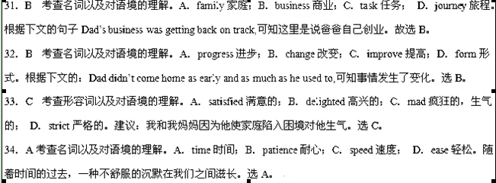 35．B 考查副词以及对语境的理解。A．occasionally偶然地；B．early早地；C．frequently频繁地；D．rarely罕见地。根据下文的：Dad was home early可知在作者过生日的时候，爸爸早早回来了。选B。
36．C考查动词以及对语境的理解。A．sharpen削尖；B．repair修理；C．clean打扫；D．keep保持。根据上文的：help Daddy clean it，可知爸爸这次又让作者帮他清理梳子。选C。
37．B考查动词以及对语境的理解。A．drop扔掉，掉落；B．take拿；C．hand递；D．throw扔掉。作者看了爸爸一会，拿上梳子，走向水池，选B。
38． C 考查动词短语以及对语境的理解。A．watch观看；B．let让；C．help帮助；D．hear听见。根据上文的：help Daddy clean it，可知作者小时候经常帮助爸爸清理梳子。选C。
39．D 考查动词以及对语境的理解。A．find发现；B．lose失去；C．waste浪费； D．spend度过。我小时候很高兴帮爸爸清理梳子，因为这意味着爸爸可以早早回来和妈妈和我一起度过夜晚，故选D。
40．C 考查动词以及对语境的理解。A．affect影响；B．break破坏；C．mean意味着； D．support支持。根据上文内容可知爸爸早早回来陪我和妈妈这意味着一个幸福的家庭。选C。
41．D 考查副词以及对语境的理解。A．firmly坚定地；B．hurriedly匆忙地；C．casually随意地；D．carefully仔细地。我将清理好的梳子递给爸爸，爸爸向我微笑，仔细地将它放进钱包。选D。
42．A 考查形容词以及对语境的理解。A．different不同的；B．exciting令人兴奋的；C．interesting有趣的； D．urgent紧急的。根据下文的：Dad has aged.可知作者注意到不同的事情。 选A。
43．D 考查连词以及对语境的理解。A．for因为；B．or或者；C．so因此；D．yet然而。他微笑的时候眼睛周围有皱纹，然而他的微笑还是和以前一样暖心，所以选D。
44．B 考查形容词以及对语境的理解。A．convincing令人幸福的；B．heartwarming暖心的；C．cautious谨慎的； D．innocenct天真的。根据上文的句子：He would ___ affectionately at me and place the comb on his wallet.可知爸爸看着女儿的微笑是温暖人心的，选B。
【考点定位】人生百味类完形填空
第二部分：阅读理解（共两节，满分40分）
第一节：（共15小题；每小题2分，满分30）
阅读下列四篇短文，从每小题后所给的A、B、C、D四个选项中，选出最佳选项，并在答题卡上将该选项涂黑。
A
Share with us
Would you like to have your writing published in this magazine?
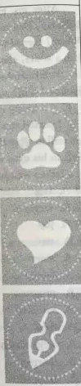
Then let us know! We pay for stories, anecdotes and jokes:
Anecdotes and Jokes
＄50
What’s made you laugh recently? A funny sign? A colleague’s be haviour? Got a joke? Send it in for Laughter is the Best Medicine!
Email: Juliet@sws.com
Smart Animals
Up to ＄100
Send us a tale about the strange behaviour of unique pets or wildlife in up 300 words.
Email: audry@sws.com
Power of Love
Up to ＄150
Acts of generosity can change lives or just give you that warm feeling full of love. Share your moments 100—500 words.
Email: susan@sws.com
My Story
＄350
Do you have an inspiring or life-changing story to tell? Your story must be true, unpublished, original and 800-1000words.
Email: nanjc@sws.com
For more information, please visit: http://www.sws.com./share
46. How much will the magazine pay for a joke to be published?
A. ＄50 B. ＄100 C. ＄150 D.＄350
47. If you want to share a story of your pets with the readers, you need to submit it to .
A. Anecdotes and Jokes B. Smart Animals
C. Power of Love D. My Story
48. A story showing people’s generosity should be emailed to the editor at .
A. juliet@sws.com B. susan@sws.com
C. Audrey@sws.com D. nanjc@sws.com
49. An inspiring story sent to the magazine should .
A. describe strange behaviour B. contain less than 800 words
C. be real and original D. be published before
【答案】
46.A
47.B
48.B
49.C
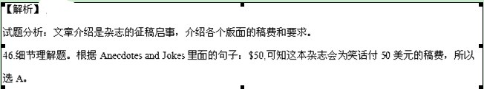 47.细节理解题。根据Smart Animals里面的句子：Send us a tale about the strange behavior of unique pets of wildlife in up to 300 words,可知如果你想和读者分享宠物的故事，你需要提交给Smart Animals，所以选B
48.细节理解题。根据Power of Love里面的句子：Acts of generosity can change lives or just give you that warm feeling full of love. 可知展示人们慷慨的故事应该用电邮发给susan@sws.com的编辑，故选B。
49.细节理解题。根据My Story里面的句子：Your story must be true, unpublished, original and 800-1000 words.可知一个激励人心的故事应该是真实的原创的，故选C。
【考点定位】广告布告类阅读理解

B
When the dog named Judy spotted the first sheep in her life, she did what comes naturally. The four-year-old dog set off racing after the sheep across several fields and, being a city animal, lost both her sheep and her sense of direction. Then she ran along the edge of cliff( 悬崖) and fell 100 feet, bouncing off a rock into the sea.
Her owner Mike Holden panicked and celled the coastguard of Cornwall, who turned up in seconds . Six volunteers slid down the cliff with the help of a rope but gave up all hope of finding her alive after a 90-minute search.
Three days later, a hurricane hit the coast near Cornwall. Mr. Holden returned home from his holiday upset and convinced his pet was dead. He comforted himself with the thought she had died in the most beautiful part of the country.
For the next two weeks, the Holdens were heartbroken . Then, one day, the phone rang and Steve Tregear, the coastguard of Cornwall, asked Holder if he would like his dog bark.
A birdwatcher, armed with a telescope, found the pet sitting desperately on a rock. While he sounded the alarm, a student from Leeds climbed down the cliff to collect Judy.
The dog had initially been knocked unconscious(失去知觉的)but had survived by drinking water from a fresh scream at the base of the cliff. She may have fed on the body of a sheep which had also fallen over the edge. “The dog was very thin and hungry,” Steve Tregear said , “It was a very dog. She survived because of a plentiful supply of fresh water,” he added.
It was ,as Mr. Holden admitted, “a minor miracle(奇迹)”.
50. The dog Jody fell down the cliff when she was
A. rescuing her owner B. caught in a hurricane
C. blocked by a rock D. running after a sheep
51. Who spotted Judy after the accident?
A. A birdwatcher B. A student from Leeds
C. Six volunteers D. The coastguard of Cornwall
52. What can we infer from the text?
A. People like to travel with their pets.
B. Judy was taken to the fields for hunting.
C. Luck plays a vital role in Judy's survival.
D. Holden cared little where Judy was buried.
53. Which of the following can be the best title for the text?
A. Miracle of the Coastguard. B. Surviving a Hurricane.
C. Dangers in the Wild D. Coming Back from the Dead.
50.D
51.A
52.C
53.D
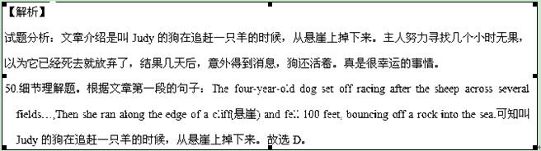
51.细节理解题。根据文章第五段的句子：A birdwatcher, armed with a telescope, found the pet sitting desperately on a rock. 可知事故后是一个观鸟者看见了Judy，故选A。
52.细节理解题。根据文章第六段的句子：It was a very lucky dog. She survived because of a plentiful supply of fresh water.可知在Judy的事故中运气起着至关重要的作用。故选C。
53.主旨大意题。根据文章的内容可知介绍一只狗掉到悬崖下面死里逃生的经历，所以用Coming Back from the Dead比较合适。故选D。
【考点定位】故事类阅读理解

C
The production of coffee beans is a huge, profitable business, but, unfortunately, full-sun production is taking over the industry and bringing about a lot of damage. The change in how coffee is grown from shade-grown production to full-sun production endangers the very existence of, certain animals and birds, and even disturbs the world’s ecological balance.
On a local level, the damage of the forest required by full-sun fields affects the area’s birds and animals. The shade of the forest trees provides a home for birds and other special(物种) that depend on the trees’ flowers and fruits. Full-sun coffee growers destroy this forest home. As a result, many special are quickly dying out.
On a more global level, the destruction of the rainforest for full-sun coffee fields also threatens(威胁)human life. Medical research often makes use of the forests' plant and animal life, and the destruction of such species could prevent researchers from finding cures for certain diseases. In addition, new coffee-growing techniques are poisoning the water locally, and eventually the world's groundwater.
Both locally and globally, the continued spread of full-sun coffee plantations (种植园)could mean the destruction of the rainforest ecology. The loss of shade trees is already causing a slight change in the world's climate, and studies show that loss of oxygen-giving trees also leads to air pollution and global warming. Moreover, the new growing techniques are contributing to acidic(酸性的) soil conditions.
It is obvious that the way much coffee is grown affects many aspects many aspects of life, from the local environment to the global ecology. But consumers do have a choice. They can purchase shade-grown coffee whenever possible, although at a higher cost. The future health of the planet and mankind is surely worth more than an inexpensive cup of coffee.
54. What can we learn about full-sun coffee production from Paragraph 4?
A. It limits the spread of new growing techniques.
B. It leads to air pollution and global warming.
C. It slows down the loss of shade trees.
D. It improves local soil conditions.
55. The purpose of the text is to .
A. entertain B. advertise C. instruct D. persuade
56. Where does this text probably come from ?
A. An agricultural magazine.
B. A medical journal.
C. An engineering textbook.
D. A tourist guide.
57. Which of the following shows the structure of the whole text
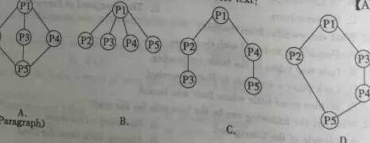
54.B
55.D
56.A
57.A
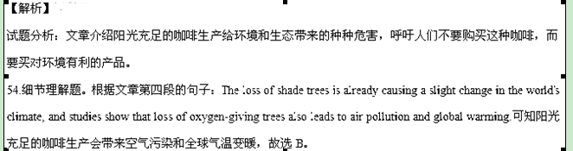 55.写作意图题。根据文章最后一段的句子：But consumers do have a choice. They can purchase shade-grown coffee whenever possible, although at a higher cost.可知作者的意图是劝说人们购买阴凉处种植的咖啡，这样对环境是有好处的，故选D。
56.推理判断题。文章介绍阳光充足的咖啡生产会带来的破坏，应该是出自一本农业杂志，故选A。
57.文章结构题。文章第一段介绍阳光充足的咖啡生产的话题，二、三、四段介绍了阳光充足的咖啡生产带来的破坏，第五段说服人们去购买对环境有利的阴凉处种植的咖啡，所以是总分总的结构，故选A。
【考点定位】环保类阅读理解

D
Parents who help their children with homework may actually be bringing down their school grades. Other forms of prenatal involvement, including volunteering at school and observing a child's class, also fail to help, according to the most recent study on the topic.
The findings challenge a key principle of modern parenting(养育子女) where schools except them to act as partners in their children's education. Previous generations concentrated on getting children to school on time, fed, dressed and ready to learn.
Kaith Robinson, the author of the study, said, "I really don't know if the public is ready for this but there are some ways parents can be involved in their kids' education that leads to declines in their academic performance. One of the things that was consistently negative was parents' help with homework." Robinson suggested that may be because parents themselves struggle to understand the task." They may either not remember the material their kids are studying now, or in some cases never learnt it themselves, but they're still offering advice."
Robinson assessed parental involvement performance and found one of the most damaging things a parent could do was to punish their children for poor marks. In general, about 20% of parental involvement was positive, about 45% negative and the rest statistically insignificant.
Common sense suggests it was a good thing for parents to get involved because "children with good academic success do have involved parents ", admitted Robinson. But he argued that this did not prove parental involvement was the root cause of that success." A big surprise was that Asian-American parents whose kids are doing so well in school hardly involved. They took a more reasonable approach, conveying to their children how success at school could improve their lives."
58. The underlined expression "parental involvement " in Paragraph 1 probably means .
A. parents' expectation on children's health
B. parents' participation in children's education
C. parents' control over children's life
D. parents' plan for children's future
59. What is the major finding of Robinson's study ?
A. Modern parents raise children in a more scientific way.
B. Punishing kids for bad marks is mentally damaging.
C. Parental involvement is not so beneficial as expected.
D. Parents are not able to help with children’s homework.
60. The example of Asian-American parents implies that parents should .
A. help children realize the importance of schooling
B. set a specific life goal for their children
C. spend more time improving their own lives
D. take a more active part in school management
58.B
59.C
60.A
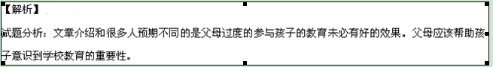 58.句意理解题。根据第一段的句子：Other forms of parental involvement, including volunteering at school and observing a child’s class,可知“parental involvement”指的是“父母参与孩子的教育”，故选B。
59.细节理解题。根据文章第二段的句子：but there are some ways parents can be involved in their kids’ education that leads to declines in their academic performance.可知Robinson的研究发现是父母参与孩子的教育没有预料的那么有效，故选C。
60.细节理解题。根据文章最后一段的句子：They took a more reasonable approach, conveying to their children how success at school could improve their lives.可知美国父母的例子暗示父母应该帮助孩子意识到学校教育的重要性，故选A。
【考点定位】教育类阅读理解
第二节 （共5小题；每小题2分，满分10分）
根据短文内容，从下框的A~F选项中选出能概括每一段主题的最佳选项，并在答题卡上将该选项涂黑。选项中有一项为多余项。
A. The mistaken belief
B. The need for tolerance
C. Unpunctuality at dinners
D. Punctuality and confidence
E. Self-discipline and punctuality
F. Avoid anxiety by being punctual
61. A
There is the belief that, if you arrive at an appointment late, you will be considered important. This is a mistaken view. Being unpunctual, we are not respectful of others ; we are interfering (扰乱)with another man's time. We must realise that keeping appointments or being punctual is a contract that is silently agreed and we are expected to respect this contract. It is only natural that we lose faith, trust and confidence in a person who is tardy(延迟的).
62. E
To be punctual one has to have self-discipline(自律), and the lack of it affects others. A school boy or girl is unpunctual because he or she does not have the necessary human virtue of self-discipline. It is also a mark of disrespect for a system or an institution. Unpunctual people seldom realise that their habit cause problems to others. A salesman who is not punctual may not make a sale if he arrives late for an appointment. If one is late for a job interview, it is not likely that he will get the job.
63. F
Being punctual, we can avoid anxiety. Imagine the anxiety if you do not want to be considered unpunctual. You will be anxious if you set out for a dinner late. The person who sets out late might be careless in driving. He will ignore traffic rules. A traffic jam, flat tyres, etc. can delay him further. Happy and calm is the man who takes all these possibilities into consideration and arrives at the appointment either early or on time.
64. C
Many of those who attend dinners are notorious (声名狼藉的)for unpunctuality. They ignore the appointed time and leave their homes only after the fixed time. They are indifferent to the inconvenience caused to others. If the self-centred guest arrives late, the nine others at the table set for ten will have to wait. The host is put in an unpleasant situation and this man seldom thinks of the inconvenience caused to all -the waiters, the management staff, etc. It is necessary for us to think of others and be considerate to them.
65 B
However, we cannot always be intolerant (无法容忍的) of tardiness, for ordinary living requires some tolerance. There can be a busy executive who fights to keep to his schedule. Such a person may be forgiven if he is late, but not those who are deliberately late to create impression.
In modern society, punctuality is a necessary virtue. It is a recognition of the importance of other people.
【答案】
61.A
62.E
63.F
64.C
65.B
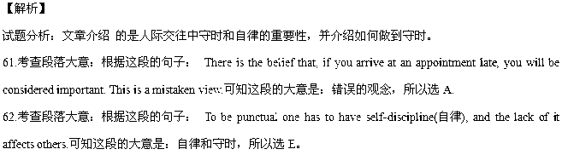 63.考查段落大意：根据这段的句子： Being punctual, we can avoid anxiety. Imagine the anxiety if you do not want to be considered unpunctual.可知这段的大意是：避免守时造成的焦虑，所以选F。
64.考查段落大意：根据这段的句子： Many of those who attend dinners are notorious (声名狼藉的)for unpunctuality.可知这段的大意是：就餐时不守时，所以选C。
65.考查段落大意：根据这段的句子： However, we cannot always be intolerant (无法容忍的) of tardiness, for ordinary living requires some tolerance.可知这段的大意是：需要容忍，所以选B。
【考点定位】考查信息匹配

第三部分 写作（共三节，满分55分）
第一节 单词拼写（共10题；每题1分，满分10分）
根据下列各句句意和空白之后的汉语提示词，在答题卡指定区域的横线上写出对应单词的正确、完整形式，每空只写一词。
66. Cecily, I shall_________ (想念) our pleasant talks when you leave.
67. Hans Zhang was _________ (自豪的) of himself for not giving up.
68. The teacher asked one student to _________ (重复) what he had heard from the tape recorder.
69. Young people should always___________ (对待) the elders with respect.
70. Tourism is the major source of ___________ (收入) for this area.
71. Our class president went up to Cambridge at the age of 15 to study ____________ (化学) .
72. For your own ____________ (安全), please keep away from the tiger cage.
73. It was pouring with rain so I ____________(接受) his offer of a lift.
74. In a week, Lucy has already been interviewed by six ___________ ( 医院).
75. After knocking ____________ (礼貌地) at the door, the applicant entered the office of the general manager.
【答案】
66.miss
67.proud
68.repeat
69.treat
70.income
71.chemistry
72．safety
73.accepted
74.hospitals
75.politely
【解析】
试题分析：
66.句意：Cecily，当你离开的时候我会想念我们之间愉快的谈话。考查动词“想念”：miss。
67.句意：Hans Zhang对自己不放弃而引以为荣。考查形容词“自豪的”：proud。
68.句意：老师让每个学生重复他在录音机上听到的东西。考查动词“重复”：repeat。
69.句意：年轻人应该总是尊敬地对待老人。考查动词“对待”：treat。
70.句意：旅游业是这个地区主要的收入来源。考查名词“收入”：income。
71.句意：我们班的主席在15岁的时候去剑桥学习化学。考查名词“化学”： chemistry。
72.句意：为了你自己的安全，请远离老虎笼。考查名词“安全”，safety。
73.句意：下着倾盆大雨，我接受他搭我一程的邀请。”考查动词“接受”；因为前面用了was，所以用一般过去时，故填accepted。
74.句意：一周内，Lucy已经被六个医院面试了。考查名词“医院”和six搭配用复数，故填hospitals。
75.句意：在礼貌地敲了门后，这个申请人进入总经理的办公室。考查副词“礼貌地”： politely。
【考点定位】考查单词拼写
第二节 短文改错（共10小题；每小题1.5分，满分15分）
假定英语课上老师要求同桌之间交换修改作文，请你修改你同桌系的以下作文。文中共有10处语言错误，每句中最多有两处。错误涉及一个单词的增加、删除或修改。
增加：在缺词处加一个漏词符号（∧），并在其下面写出该加的词。
删除：把多余的词用斜线（ ）划掉。
修改：在错的词下划一横线（ ），并在该词下面写出修改后的词。
注意：1.每处错误及修改均仅限一词；
2.只允许修改10处，多者（从第11处起）不计分。
My soccer coach retired in last week. I wanted to do anything special for him at his retirement party. My mum makes the better biscuits in the world, so I decide to ask her for help. Mum taught me some basic step of baking. I insisted on doing most of the baking myself. I thought the biscuits were really well. My only mistake was that I dropped some on the floor after I was packing them up.
At a party, my coach, with a biscuit in his mouth, asked surprisingly who made them and joked, “I might have to retire again next year just get some more of these biscuits.”
My favorite picture at the party is of my coach and me enjoy the biscuits with happy laughter!
【答案】
76.去掉in
77.anything 改为something
78.better改成best
79.decide改成decided
80.step 改为steps
81.well改成good
82.after改成when/while
83.a改为the
84.just后加to
85.enjoy改为enjoying
【解析】
试题分析：文章介绍作者的教练退休了，在退休聚会上作者送给教练自己亲手烘焙的饼干。教练非常高兴。
76．句意：我的足球教练上个星期退休了。Last week前面不加介词，去掉in。
77.句意：我想在他退休聚会上为他做些特别的事情。肯定句用something。
78.句意：我妈妈做的是世界上最好的饼干。用最高级，better改成best。
79.句意：所以我决定向她求助。这篇文章使用一般过去时，decide改成decided。
80.句意：妈妈教我一些基本的烘焙的步骤。step 是可数名词，用复数steps。
81.句意：我认为这些饼干很好。做表语用形容词，well改成good。
82.句意：我唯一的错误是在我将它们打包的时候将它们掉在地上。after改成when/while
83.这里是特指第一段提到的退休聚会。a改为the。
84.句意：我可能明年要再退休一次，只是想得到更多这样的饼干。用不定式做目的状语。just后加to。
85.句意：我最喜欢的照片是我和我的教练在聚会上开心地享受饼干。of后面接动名词，my coach and me是逻辑主语，enjoy改为enjoying。
【考点定位】考查短文改错

第三节 书面表达（满分30分）
假定你是李华。在校报英语专栏看到了学校“英语文化节”的一则招募启事，请阅读启事，并根据写作要点和写作要求写一封应征邮件。
Volunteers Wanted
Our annual English Festival, which will be held on June 15-17, 2015, is now looking for 20 student volunteers to provide service for Talent Show, Speech Contest, and English Debate. If you are interested, please send an application email at your earliest convenience to Ms.Chen at chenlaoshi@aef.com.

写作要点：
1.表示写信意图；
2.陈述应征目的；
3.说明应征条件（性格、能力等）。
写作要求：
1.邮件词数不少于100；
2.开头和结尾部分已写好，不计入总词数；
3.可根据情况增加细节，使行文连贯
4.不能使用真实姓名和学校名称。
Dear MS Chen ,
I’m Li Hua, a student from Class2, Grade 3. ______________________________________________________________________________________________________________________________________________________________________________________________________________________________________________________________________________________________________________________________________________________________________________________________________________________________________________________________________________
Looking forward to your reply.
Yours truly,
Li Hua
【参考答案】
Dear MS Chen ,
I’m Li Hua, a student from Class2, Grade 3. I’m writing to apply for the position as a student volunteer.
I really want to obtain this precious opportunity because, by offering my service, I will be able to improve my organizational ability, communication skills as well as my confidence in speaking English in public.
As an outgoing girl, I get along well with my classmates. Besides, I have such a good command of English that I am elected as assistant to my English teacher. Successfully, I have lent a helping hand to her in several English activities of my class, which have been appreciated by both teachers and classmates.
I am sure that I can perfectly live up to your expectations. I will be gratefull if you could give me a kind consideration.
Looking forward to your reply.
Yours truly,
Li Hua
【解析】
试题分析：本篇书面表达属于英文书信，根据提示可知需要结合“英语文化节”的一则招募启事写一封应征邮件。写作时注意以下几点：1、仔细阅读招募启事，弄清招募职位所有信息和要求；2、根据写作要点从三个方面写应征邮件。写作时可以按照要点所给的顺序写。3、根据要表达的内容确定句子的时态、语态；就本文而言应该用一般现在时态。 4.注意使用高级词汇和句式，以增加文章的亮点。
【亮点说明】本文结构紧凑，层次分明，而且使用了多种句式和结构。比如I have such a good command of English that I am elected as assistant to my English teacher.运用了so…that…句型，以及定语从句I have lent a helping hand to her in several English activities of my class, which have been appreciated by both teachers and classmates.。此外，文章还使用了大量短语，如apply for the position, as well as, in public, get along well with,,have such a good command of, lent a helping hand to, live up to等。插入语Besides，以及副词Successfully的使用使文章内容更具有层次感，也使语言更加连贯。
【考点定位】考查提纲作文

