
绝密★ 启封并使用完毕前
2015年普通高等学校招生全国统一考试(四川卷)
英 语
本试题卷分第Ⅰ卷（选择题）和第Ⅱ卷（非选择题）。第Ⅰ卷至8页，第Ⅱ卷9至10页，
共10页。满分150分。考试时间120分钟。考生作答时，须将答案答在答题卡上，在本试题卷、草纸上答题不小。考试结束后，将本试题卷和答题卡一并交回

第Ⅰ卷（选择题共90分）
注意事项：
- 必须使用2B铅笔在答题卡上将所选答案对应的标号涂黑
- 第Ⅰ卷共两部分，共计90分。
第一部分英语知识运用（共两节，共40分）
- 单项填空
从A、B、C、D四个选项中，选出可以填入空白处的最佳选项，并在答题卡上将该项涂黑。（共10小题；每小题1分，共10分）
1.—Sorry, I forgot to lock the door.
—______ Mike can do it later..
- No way B. Take your time C. Nothing serious D. You're welcome
【答案】C
【解析】
.试题分析:考查情景交际.选项A意为没门，选项B意为漫漫来;选项C意为没什么大不了的;选项D.
意为不客气.此题上文意为:对不起，我忘了锁门;下文意为Mike稍后会做的，根据语境选择C最为洽当.
考点：考查情景交际
2.You _____be careful with the camera. It costs!
A .must B. may C. can D. will
【答案】A
【解析】
试题分析：考查情态动词。根据下文的it costs可知，照相机很昂贵，故选择A，意为你一定要非常小心对待照相机，它很昂贵。
考点：考查情态动词
3.The books on the desk, covers are shiny, are prizes for us.
A．which B. what C. whose D. that
【答案】C
【解析】
试题分析：考查定语从句。本题考查定语从句的连接词，先行词为the books，和covers之间存在所有关系，故选择C，意为书的封面。句意为：桌上的书是给我们的奖励，那些书的封面闪闪发光。
考点：考查定语从句
4.More expressways in Sichuan soon to promote the local economy.
A. are being built B. will be built C. have been built D. had been built
【答案】B
【解析】
试题分析:考查时态.本句为时态题，根据时if}状语soon可知，考查了将来时，故选择B.句意为:四1iM
将建设更多的高速公路以促讲当地的经济.
考点：考查时态
5.Brian is gifted in writing music; he is very likely to beBeethoven.
A. a B. an C. the D.不填
【答案】A
【解析】
试题分析：考查冠词。本题考查不定冠词在人名前，表示：一个像…那样的人。故选择A，句意为：Brian在创作音乐上极有才华，他很有可能成为一个像贝多芬那样的人才。
考点：考查冠词
6.There is only one more day to go your favorite music group play live.
A. since B. until C. when D. before
【答案】D
【解析】
试题分析：考查连词。选项A意为自从；选项B意为直到；选项C意为当…时；选项D意为在…之前。此题前一分句意为：还有一天；后一分句意为：你最喜欢的乐队现场表演。根据句意选择D，句意为：还有一天你最喜欢的乐队将会现场演奏。
考点：考查连词
7.Andy is content with the toy. It is he has ever got.
A. a better B. the better C. a best D. the best
【答案】D
【解析】
试题分析：考查最高级和比较级。根据上一句话可知，Andy对这个玩具很满意，故选择D，意为：这是他曾得到的最好的玩具。
考点：考查最高级和比较级
8.The exhibition tells uswe should do something to stop air pollution.
A. where B. why C. what D. which
【答案】B
【解析】
试题分析:考查宾语从句.本句考查宾语从句的连接词.宾语从句中不缺少主语和宾语，故选项C错误，
选项D担当定语，也错误.根据意思:这个展览告诉了我们，我们为什么要停止空气污染而不是我们在哪
J6停止空气污染，故选择B.
考点：考查宾语从句
9.Little Tom sat watching the monkey dancing in front of him.
A. amaze B. amazing C. amazed D. to amaze
【答案】C
【解析】
试题分析：本句考查形容词作状语。本句考查形容词作伴随状语，意为：小Tom坐在那儿看着小猴子在他面前跳舞，很吃惊。主要考查B、C之间的区别，选项B意为：令人吃惊的，常修饰物；而选项C意为：感到吃惊的，常修饰人。根据句意，本题选择C。
考点：考查形容词作状语
10.Niki is always full of ideas, butis useful to my knowledge.
A. nothing B. no one C. neither D. none
【答案】D
:【解析】
呢
一试题分析:考查代词.选项a意为什么都没有、没有东西;不和of连用，故选项a错误。选项B只可以翻.指人，故选项B错误.选项c意为两者都不，语意不符.选项D可指人也可指物，相当于no-n,故此题选择D.句意为:Niki总是有很多想法，但是没有一个想法对我的知识有用.
考点：考查代词
第二节 完形填空
阅读下面短文，从短文后各题所给的四个选项（A、B、C、D）中，选出可以填入空白处的最佳选项，并在答题卡上将该项涂黑。（共20小题；每小题1.5分，共30分）
My previous home had a stand of woods behind it and many animals in the backyard. That first year, I_11__ feeding peanuts to the blue jays, then the squirrels. The squirrels had no__12__ coming up right to me for them. As the months went by, the rabbits saw that I was no 13 and didn’t escape. When I threw carrot slices(薄片)，they even came for a nibble(啃).Slowly they came to_14___ me, and by the end of the year they were eating out of my hand.
That second year, the rabbits__15___ me, and one would even sit up for slices! While I was feeding them, I _16___ that a groundhog who used to run away was now talking an___17___interest in this food situation. I carefully extended a long__18____, with a keen eye on those teeth, and _ 19 __,there were times I would have the groundhog sitting next to a rabbit, both munching(津津有味的咀嚼) on carrots. A few months later, while ___20___,she would even turn her back to me.___21 _when she was facing away, I reached out and ___22__scratched（搔）her back with my finger, She didn’t move.
By year three, the rabbits and the groundhog were back. The groundhog ___23__didn’t have a problem with me scratching her back, and I got an ides, I’d always___24__,while slicing up carrots, that the end looked like a cap.___25___one day, just to see what she would do ,I gently ___26__ one on top of the groundhog’s head. Again, not a ___27__,The next time, I had my camera ready to record what you see here, one of several dozen such pictures,____28___she had a slice to eat, she never ___29___ the one of her head. It was a fair __30__ —I got a pleasure, and she had yet another tasty treat.
- A. avoided B. started C. canceled D. suggested
- A. business B. fun C. problem D. privilege
- A . help B. cheat C. threat D. exception
- A. trust B. miss C. admire D. appreciate
- A. feared B. ignored C. discovered D. remembered
- A. proved B. decided C. noticed D. understood
- A. extreme B. increasing C. additional D. inspiring
- A. squirrel B. rabbit C. peanut D. carrot
- A. before long B. long ago C. over and over D. all over again
- A. eating B. playing C. sitting D. sleeping
- A. Next B. Once C. Soon D. Lately
- A. carefully B. suddenly C. violently D. patiently
- A. also B. thus C. just D. still
- A. thought B. doubted C. admitted D. recognized
- A. While B. Or C. So D. For
- A. fixed B. placed C. hung D. kept
- A. tremble B. move C. delay D. hesitation
- A. Even if B. Ever since C. As far as D. So long as
- A. welcomed B. required C. bothered D. expected
30. A. trade B. competition C. task D. affair
【答案】
11. B
12. C
13. C
14. A
15. D
16. C
17. B
18. D
19. A
20. A
21. B
22. A
23. D
24. A
25. C
26. B
27. B
28. D
29. C
30. A
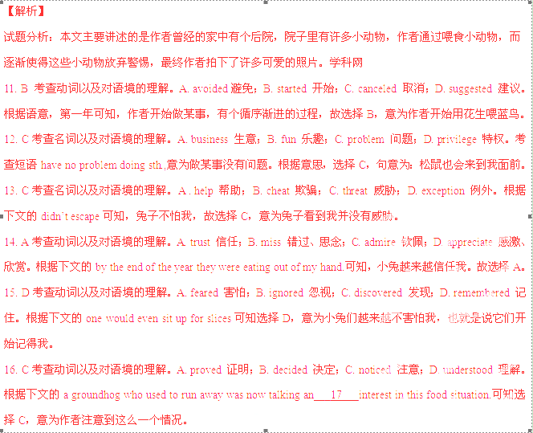
17. B考查形容词以及对语境的理解。A. extreme 极端的；B. increasing 不断增长的；C. additional 额外的；D. inspiring 鼓舞人心的。根据下文的土拨鼠逐渐不怕作者可知，选择B，指土拨鼠开始对…越来越感兴趣。
18. D考查名词以及对语境的理解。A. squirrel 松鼠；B. rabbit 兔子；C. peanut 花生；D. carrot 胡萝卜。根据下文的both munching(津津有味的咀嚼) on carrots.可知选择D，意为我把胡萝卜伸给土拨鼠吃。
19. A考查连词以及对语境的理解。A. before long 不久之后；B. long ago 很久之前；C. over and over 一次又一次；D. all over again 再一次。根据下文可知，土拨鼠不怕作者，故选择A，指不久之后的情况。
20. A考查动词以及对语境的理解。A. eating 吃；B. playing 玩；C. sitting 坐；D. sleeping 睡觉。根据上文可知在津津有味地吃胡萝卜，故选择A。
21. B考查副词以及对语境的理解。A. Next 下一次；B. Once 曾经、一次；C. Soon 很快；D. Lately 最近、近来。根据句意选择B，意为曾经有一次，当她转过身时，…。
22. A考查副词以及对语境的理解。A. carefully 仔细地、小心地；B. suddenly 突然；C. violently 暴力地；D. patiently 有耐心地。根据上文可知，作者是慢慢让动物不再害怕他，故选择A，指作者小心翼翼地伸出手去搔她的背。
23. D考查副词以及对语境的理解。A. also 也；B. thus 因此；C. just 正好、恰恰；D. still 仍然。根据上文的by year three ,可知，到了第三年动物仍然不怕他，故选择D。
24. A考查动词以及对语境的理解。A. thought 认为；B. doubted 怀疑；C. admitted 承认；D. recognized 意识。根据下文的that the end looked like a cap可知，这是作者的想法，故选择A。
25. C考查连词以及对语境的理解。A. While 当…时；B. Or 否则；C. So 因此；D. For 因为。根据上文可知，作者认为胡萝卜根部像帽子，然后有一天他就把它当帽子用了，故选择C。
26. B考查动词以及对语境的理解。A. fixed 安装；B. placed 放置；C. hung 悬挂；D. kept 维持。根据句意，选择B，因为作者把胡萝卜根部当帽子戴在土拨鼠的头上，故选择B。
27. B考查动词以及对语境的理解。A. tremble 颤抖；B. move 动；C. delay 推延；D. hesitation 犹豫。根据上文的again，可知，土拨鼠没有动，故选择B。
28. D考查连词以及对语境的理解。A. Even if 即使；B. Ever since 自从；C. As far as 就…而言；D. So long as 只要。根据意思，选择D，意为只要有胡萝卜片吃，…。
29. C考查动词以及对语境的理解。A. welcomed 欢迎；B. required 要求；C. bothered 烦恼；D. expected 期待。根据上文可知，只要她有的吃，她就不会烦恼头上这片了，故选择C。
30. A考查名词以及对语境的理解。A. trade 交易；B. competition 竞争；C. task 任务；D. affair 事务。根据句意选择A，意为这是一个公平的交易。
考点：考查记叙文阅读
第二部分 阅读理解（共两节，共50分）
第一节 阅读下列短文，从每题所给的四个选项（A、B、C、D）中，选出最佳选项，并在答题卡上将该项涂黑。（共20小题；每小题2分，共40分）

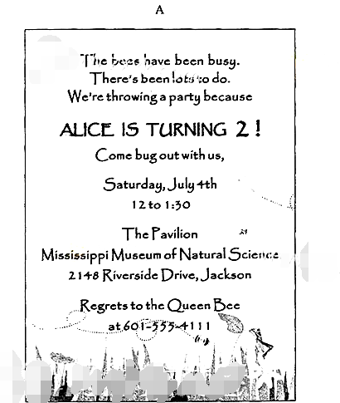

31.The card above is_________
A. a ticket B. a postcard
C. an invitation D. an advertisement
32.The party is for_________
A. a birthday
B. the Queen
C. bee watching
D. the National Day
33.According to the card ,if you are unable to go ,you can.
A. return the card
B. visit the Museum
C. ignore the message
D. contact Alice’mother
【答案】
31.C
32.A
33.D
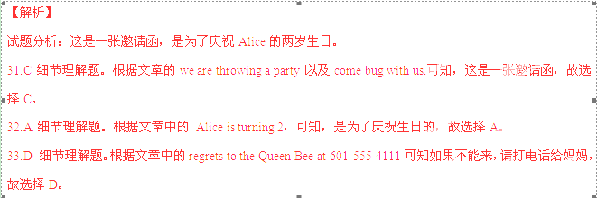
考点：考查应用文阅读

B
Nothing could stop Dad. After he was put on disability for a bad back, he bought a small farm in the country, just enough to grow food for the family. He planted vegetables, fruit trees and even kept bees for honey.
And every week he cleaned Old Man McColgin's chicken house in exchange for manure(肥料). The Smell really burned the inside of your nose. When we complained about the terrible smell, Dad said the stronger the manure, the healthier the crops, and he was right. For example, just one of his cantaloupes filled the entire house with its sweet smell, and the taste was even sweeter.
As the vegetables started coming in, Dad threw himself into cooking. One day, armed with a basket of vegetables, he announced he was going to make stew(炖菜).Dad pulled out a pressure cooker and filled it up with cabbages, eggplants, potatoes, corns, onions and carrots. For about half an hour. the pressure built and the vegetables cooked. Finally, Dad turned off the stove, the pot began to cool and the pressure relief valve sprayed out a cloud of steam. If we thought Dad's pile of chicken manure was bad, this was 10 times worse. When Dad took off the lid, the smell nearly knocked us out.
Dad carried the pot out and we opened doors and windows to air out the house. Just how bad was it? The neighbors came out of their houses to see if we had a gas leak!
Determined, Dad filled our plates with steaming stew and passed them around it didn’t look that bad, and after the first wave had shut down my ability to smell, it didn’t offend the nose so much, edible, and we drank up every last drop of soup.
34.Why did Dad clean Old Man Mocolgin’s chicken house regularly?
A. To earn some money for the family.
B. To collect manure for his crops.
C. To get rid of the terrible smell.
D. To set a good example to us.
35.What can we infer about Dad’s stew?
A. It is popular among the neighbors.
B. It contains honey and vegetables.
C. It looks very wonderful.
D. It tastes quite delicious.
36.What does the underlined word “offend” in the last paragraph mean?
A. To attract B. To upset C. To air D. To shut
37.What can we learn about Dad form the text?
A. He is an experienced cook.
B. He is a troublesome father.
C. He has a positive attitude to life.
D. He suffers a lot from his disability.
【答案】
34.B
35.D
36.B
37.C
【解析】
试题分析：本文主要讲述了作者的父亲买了一个小农场，在里面种满了各种蔬菜、果树甚至还养了蜜蜂。
但作者的父亲收获的时候，他炖了一锅蔬菜，闻到味道时，作者和其他人觉得烧得很糟糕，但是最后全部都吃光了。
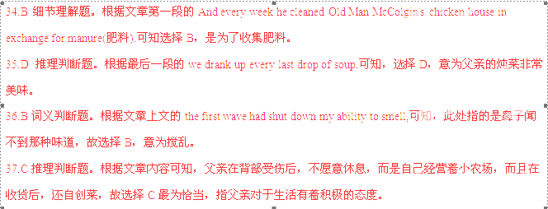
考点：考查记叙文阅读

C
Across Britain, burnt toast will be served to mothers in bed this morning as older sons and daughters to deliver their supermarket bunches of flowers, But, according to a new study, we should be placing a higher value on motherhood all year.
Mothers have long known that their home worked was just heavy as paid work. Now, the new study has shown that if they were paid for their parental labours, they would earn as much as＄172,000 a year.
The study looked at the range of jobs mothers do, as well as the hours they are working, to determine the figure. This would make their yearly income ￡3000 more than the Prime Minister earns.
By analysing the numbers, it found the average mother works 119 hours a week,40 of which would usually be paid at a standard rate 79 hours as overtime. After questioning 1,000 mothers with children under 18,it found that ,on most days, mums started their routine work at 7am and finished at around 11pm.
To calculate just how much mothers would earn from that labour,it suggested some of the roles that mums could take on, including housekeeper, part-time lawyer, personal trainer and entertainer. Being a part-time lawyer, at ￡48.98 an hour, would prove to be the most profitable of the “mum jobs”,with psychologist（心理学家）a close second.
It also asked mothers about the challenges they face, with 80 percent making emotional（情感的） demand as the hardest thing about motherhood.
Over a third of mums felt they needed more training and around half said they missed going out with friends.
The study shoes mothers matter all year long and not just on, Mother’s Day. The emotional ,physical and mental energy mothers devote to their children can be never-ending, but children are also sources of great joy and happiness. Investing（投入）in time for parenting and raising relationships is money well spent.
38.How much would a mother earn a year if working as the Prime Minister?
A.￡30,000. B.￡142,000.
C.￡172,000. D.￡202,000.
39.The biggest challenge for most mothers is from.
A. emotional demand B. low pay for work
C. heavy workload D. lack of training
40.What is stressed in the last paragraph?
A. Mothers’importance shows in family all year long.
B. The sacrifices mothers make are huge but worthwhile.
C. Mothers’devotion to children can hardly be calculated.
D. Investing time in parenting would bring a financial return.
41.What can we conclude from the study?
A. Mothers’working hours should be largely reduced.
B. Mothers should balance their time for work and rest.
C. Mothers’labour is of a higher value than it is realised.
D .Mothers should be freed from housework for social life.
【答案】
38.B
39.A
40.B
41.C
【解析】：这是一篇写在母亲节的文章，在母亲节这一天，每个人都会对母亲做出一些事，比如一束花等等，但是作者认为，母亲这一职业值得全年的关注，因为它包含太多。
38.B细节理解题。根据文章的they would earn as much as＄172,000 a year.以及This would make their yearly income ￡3000 more than the Prime Minister earns.可知，总理的工资是172000-3000=142000。故选择B。
39.A 细节理解题。根据文章倒数第三段的It also asked mothers about the challenges they face, with 80 percent making emotional（情感的） demand as the hardest thing about motherhood.可知，选择A。
40.B 细节理解题。根据最后一段的The emotional ,physical and mental energy mothers devote to their children can be never-ending, but children are also sources of great joy and happiness.可知，选择B，指母亲付出的牺牲是巨大的，但是又是值得的。
41.C 推理判断题。根据文章第一段的But, according to a new study, we should be placing a higher value on motherhood all year.可知，作者认为母亲的重要性应该得到更多的关注，故选择C。
考点：考查说明文阅读

D
Their cheery song brightens many a winter's day. But robins are in danger of wearing themselves out by singing too much. Robins are singing all night一as well as during the day, British-based researchers say.
David Dominoni, of Glasgow University, said that light from street lamps, take away signs and homes is affecting the birds' biological clock, leading to them being wide awake when they should be asleep.
Dr Dominoni, who is putting cameras inside nesting boxes to track sleeping patterns, said lack of sleep could put the birds’ health at risk. His study shows that when robins are exposed to light at night in the lab, it leads to some genes being active at the wrong time of day. And the more birds are exposed to light, the more active they are at night.
He told people at a conference, "There have been a couple of studies suggesting they are increasing their song output at night and during the day they are still singing. Singing is a costly behaviour and it takes energy. So by increasing their song output, there might be some costs of energy."
And it is not just robins that are being kept awake by artificial light. Blackbirds and seagulls are also being more nocturnal. Dr Dominoni said, "In Glasgow where I live, gulls are a serious problem. I have people coming to me saying `You are the bird expert. Can you help us kill these gulls?'.During the breeding(繁殖)season, between April and June, they are very active at night and very noisy and people can't sleep."
Although Dr Dominoni has only studied light pollution, other research concluded that robins living in noisy cities have started to sing at night to make themselves heard over loud noise.
However, some birds thrive(兴旺)in noisy environments. A study from California Polytechnic University found more hummingbirds in areas with heavy industrial machinery. It is thought that they are capitalising on their predators(天敌)fleeing to quieter areas.
42.According to Dr Dominoni's study, what cause robins to sing so much?
A. The breeding season. B. The light in modem
C. The dangerous environment. D. The noise from heavy machinery.
43.What is the researchers' concern over the increase of birds' song output?
A. The environment might be polluted.
B. The birds' health might be damaged.
C. The industry cost might be increased.
D. The people's hearing might be affected.
44.What does the underlined word "nocturnal" in Paragraph 5 mean?
A. Active at night. B. Inactive at night.
C. Active during the day. D. Inactive during the day.
45.Why do some birds thrive in noisy environments?
A. Because there are fewer dangers.
B. Because there is more food to eat.
C. Because there is less light pollution
D. Because there are more places to take shelter.
【答案】
42.B
43.B
44.A
45.A
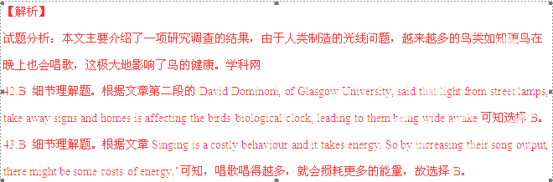
44.A 词义辨析题。根据上文的And it is not just robins that are being kept awake by artificial light. Blackbirds and seagulls are also being可知乌鸦和海鸥情况也一样，也就是说这两种鸟晚上也唱歌，故选择A，指晚上很兴奋。
45.A 细节理解题。根据文章最后一段的It is thought that they are capitalising on their predators(天敌)fleeing to quieter areas.可知，它们的天敌都去了安静的地方，故选择A，指在这些工业区，天敌更少，也就是危险更少。
考点：考查说明文阅读

E
No one is sure how the ancient Egyptians built the pyramids near Cairo. But a new study suggests they used a little rock‘n’roll. Long-ago builders could have attached wooden pole s to the stones and rolled then across the sand, the scientists say.
“Technically, I think what they’re proposing is possible,” physicist Daniel Bonn said.
People have long puzzled over how the Egyptians moved such huge rocks. And there’s no obvious answer. On average, each of the two million big stones weighed about as much as a large pickup truck. The Egyptians somehow moved the stone blocks to the pyramid site from about one kilometer away.
The most popular view is that Egyptian workers slid the blocks along smooth paths. Many scientists suspect workers first would have put the blocks on sleds(滑板). Then they would have dragged them along paths. To make the work easier, workers may have lubricated the paths either with wet clay or with the fat from cattle. Bonn has now tested this idea by building small sleds and dragging heavy objects over sand.
Evidence from the sand supports this idea. Researchers found small amounts of fat, as well as a large amount of stone and the remains of paths.
However , physicist Joseph West think there might have been a simpler way , led the new study . West said , “I was inspired while watching a television program showing how sleds might have helped with pyramid construction . I thought , ‘Why don’t they just try rolling the things？’ “A square could be turned into a rough sort of wheel by attaching wooden poles to its sides , he realized . That , he notes , should make a block of stone “a lot easier to roll than a square”.
So he tried it.
He and his students tied some poles to each of four sides of a 30-kilogram stone block. That action turned the block into somewhat a wheel. Then they placed the block on the ground.
They wrapped one end of a rope around the block and pulled. The researchers found they could easily roll the block along different kinds of paths. They calculated that rolling the block required about as much force as moving it along a slippery(滑的)path.
West hasn’t tested his idea on larger blocks, but he thinks rolling has clear advantages over sliding. At least, workers wouldn’t have needed to carry cattle fat or water to smooth the paths.
46.It’s widely believed that the stone blocks were moved to the pyramid site by ______.
A. rolling them on roads
B. pushing them over the sand
C. sliding them on smooth paths
D. dragging them on some poles
47.The underlined part “lubricated the paths” in Paragraph 4 means____.
A. made the path wet
B. made the path hard
C. made the path wide
D. made the path slippery
48.What does the underlined word “it”in Paragraph 7 refer to?
A. Rolling the blocks with poles attached.
B. Rolling the blocks on wooden wheels.
C. Rolling poles to move the blocks.
D. rolling the blocks with fat.
49.Why is rolling better than sliding according to West ?
A. Because more force is needed for sliding.
B. Because rolling work can be done by fewer cattle.
C. Because sliding on smooth road is more dangerous.
D. Because less preparation on path is needed for rolling.
50.What is the text mainly about ?
A. An experiment on ways of moving blocks to the pyramid site.
B. An application of the method of moving blocks to the pyramid site.
C. An argument about different methods of moving blocks to the pyramid site.
D. An introduction to a possible new way of moving blocks to the pyramid site.
【答案】
46. C
47.D
48.A
49.D
50.D
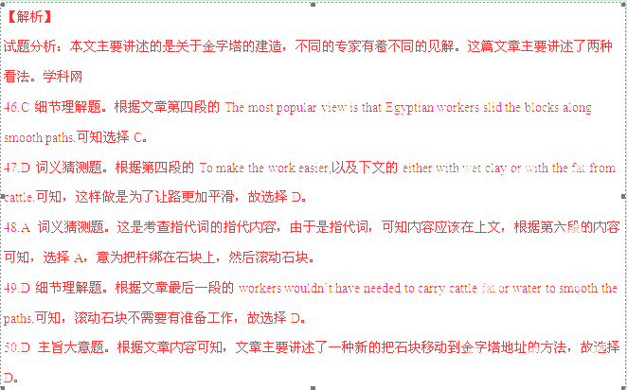
考点：考查说明文阅读
第二节 根据对话内容，从对话后的选项中选出能填入空白处的最佳选项，并在答题卡上将该项涂黑。选项中有两项多余选项。（共5小题；每小题2分，共10分）
A: I need to lose some weight. My clothes don’t fit anymore. __51___
B: Well, instead of watching TV all day, you could do more exercise.
A:_______52________
B: Like cycling, or you could work out at the gym.
A: I don’t have time. ____53____
B: OK, then you could change your diet. _____54____
A: You mean no more hamburgers! Oh no!
B: OK.___55____
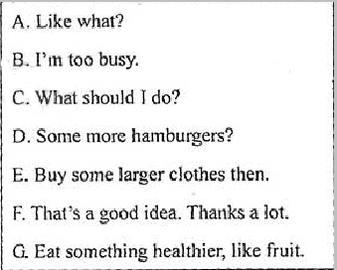
【答案】
51.C
52.A
53.B
54.G
55.E
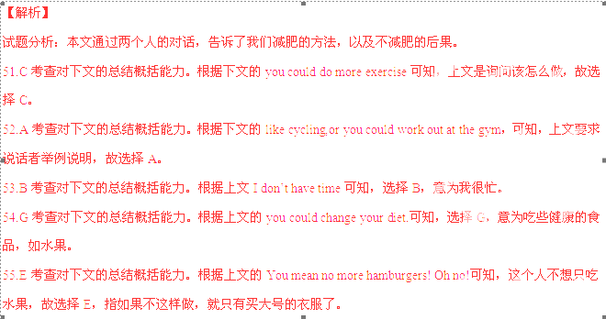
考点：考查信息匹配
第II卷 (非选择题 共60分)
注意事项：
1.必须使用0.5毫米黑色墨迹签字笔在答题卡上题目所指示的答题区域内作答，
答题在试题卷上无效
2.第I卷共三节，共计60分。
第三部分 写作（共三节，满分60分）
第一节 阅读表达：（共计5小题每小题2分，共10分）
阅读下面短文，并用英语回答问题，请清楚问题后的词数要求。
It was a hot summer day that found me running down the street with a dollar in my sweaty hand. The closer I got to Sam & Joe's Stationery Store, the more excited I was. After all, a dollar was a tidy sum for an 11-year-old boy in 1961.
Out of breath, I swung open the door and got a blast of cold air that instantly cooled me off. I was in a place of pure happiness. Sam & Joe's had it all一books, candy, toys, baseball cards，puzzles and games. I went directly to the bar and ordered a bottle of soda. There I sat, considering my next move.
Books always came first. I picked out five titles. Next came the candy, rows and rows of it. I chose five candy bars, which brought my total to 25 cents. Then a bottle of cold orange juice, a bag of chips and a pack of Ted Williams baseball cards. After paying the clerk, I still had 5 cents.
I hurried directly to my backyard, where an apple tree patiently waited for me. There, sitting in the shade against its strong trunk, I read my books, ate my candy and drank my orange juice.
As I sat in my own personal heaven，I started thinking about having more. That's when a fantastic life-changing idea popped into head: If I could get more money, could buy more books l liked. buy anything l wanted. That's how it all started.
56.How did the boy fell on his way to Sam & Joe’s(no more than 5 words)
57.What does”a tidy sum”mean in Paragraph 1?(no more than 5 words)
58.What did the boy consider doing first after he ordered soda?(no more than 5 words)
59.What did the boy do while reading?(no more than 5 words)
60.Where was the boy’s”personal heaven”?(no more than 9 words)
【答案】
56.He felt excited.
57.Much/A lot of money
58.He considered buying books.
59.He ate and drank.
60.It was under the apple tree in the backyard.
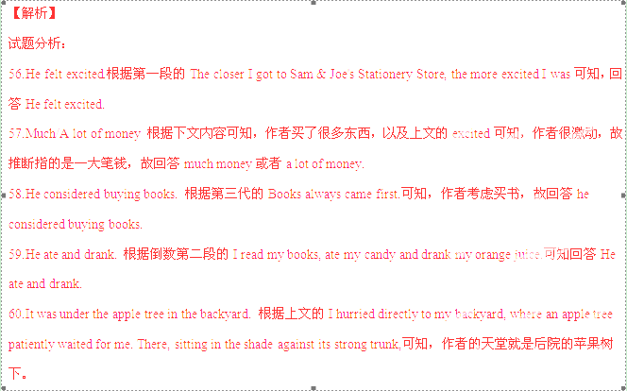
考点：考查内容归纳
第二节短文改错（共10小题；每小题1.5分，共15分）
下面短文中有10处语言错误。请在有错误的地方增加、删除或修改某个单词。
增加：在缺词处加一个漏词符号（ʌ），并在其下面写出该加的词；
删除：把多余的词用斜线（\）划掉。
修改：在错的词下划一横线，并在该词下面写出修改后的词。
注意：
- 每句不超过两个错误；
- 每处错误及其修改均仅限一次；
- 3.只允许修改10出，多者（从第11处起）不计分。

Hi, Janice,
It's been a month since I came to this new school and I really want share with you some of the
problems I have been experiencing.
As I tell you last time, I made three new friend here. We hang out together during lunch and
after school. We've been spending a lot of time sing in karaoke bars. It's been three Saturdays
now and it really costs me many. And I started to see this as a time—wasting activity! In fact ,I don’t like to go anymore, so I’m afraid I’ll lose their friendship. How do you think I should do? If you are me ,would you talk to him?
Please help with me and give me some advice.
Grace
【答案】
61.加上to
62. tell--told
63. friend--friends
64.sing--singing
65. many--much
66.so--but
67. How--What
68. are--were
69. him--them
70. 去掉with
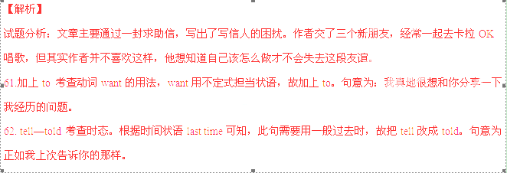
63. friend—friends 考查名词的复数。名词friend为可数名词，其前有three修饰，需要用复数形式，故把friend改成friends。句意为：我在这儿交了三个新朋友。
64.sing—singing 考查动名词担当宾语。本句考查句型spend…（in）doing sth结构，故把sing改成singing。
65. many—much 考查代词。根据句意，指的是花费很多钱，故用much而非many。句意为：那真的花费很多。
66.so--but考查连词。上一分句意为：我不想再去；下一分句意为：我怕失去他们的友谊，两个分句之间有转折关系，故把so改成but。
67. How—What 考查疑问词的选择。本句中do之后缺少宾语，表示事情，故用what而非how。注意首字母要大写。
68. are—were 考查虚拟语气。根据句子可知，此处为虚拟语气，与现在事实不相符，故把are改成were。句意为：如果你是我,…。
69. him—them 考查代词。根据上文可知，作者交了三个朋友，故用them而非him。句意为：你会和他们说吗？
70. 去掉with 考查动词。动词help为及物动词，其后接宾语时无需加介词，故去掉with。句意为：请帮帮我，给我一些建议。
考点：考查短文纠错
- 书面表达（共35分)
71.假如你是李夏。你看到美国留学生Sharon 在网上发贴，.希望有人能帮助她提高普通话（Mandarin）水平，她可以教英语作为回报。请根据以下提示用英语给她写一封电子邮件。
- 表达给她提供帮助的意愿；
- 说明你能胜任辅导的理由；
- 给出讲好普通话的两点建议；
- 提出你学习英语的具体需求。
注意：
- 词数120左右，开头语已为你写好；
- 可以适当增加细节，以使行文连贯；
- 文中不得透漏个人姓名和学校名称；
Hi Sharon,
This is Li Xia. I learned from your post that you want to improve your Mandarm
__________________________________________________________________________________________________________________________________________________________________________________________________________________________________________________________________________________________
【参考答案】
Hi Sharon,
This is Li Xia. I learned from your post that you want to improve your Mandarin. I am quite interested in it . I think I’m fit for it. As a student, I have been learning Mandarin for many years. In addition ,I am Chinese, which means Mandarin is a must for me to communicate with others in my daily life. So I’m quite confident thatI can help you learn Mandarin.
Learning Mandarin takes time, so if you want to learn it well ,you should spend much time practicing Mandarin everyday. As the saying goes, practice makes perfect. Besides, you can also read some books in Chinese、see some Chinese films and listen to some Chinese radio programmes. Speaking and listening are very important for a language learning, by which you are sure to make great progress.
In your post, you say you can teach English as a reward. It is just what I want. I’m eager to improve my English. So, if you allow me to help you learn Mandarin, you can also help me improve my English.We can contact each other by video chat every night for half an hour in English and half an hour in Chinese, so that we can improve our oral speaking.
Hope for you early reply!
Yours Sincerely
Li Xia
【解析】
试题分析:考查提纲类作文.提纲作文在写作时需要注意以下几个方面:首先需要审题.即:审要求、审
文体、审人称、审时态.其次，考生要能够抓中心，列要点，列出写作提纲.写作文时，一定要切题，抓
，住中心，紧扣要点.然后在体裁明确、中心突出、要点清晰的前提下，考生应该选择自己最熟悉、最有把
握的词语、句型，将要点逐条表达出来.最后根据要点选词组句，然后按照篇章结构连句成篇.本篇文章
的要点具体，可分成三段写，第一段写要点1. 2;第二段写要点3;第三段写要点4, 1以及希望得到对方的
.回信.
【亮点说明】本文要点齐全，结构完整。使用多种句式，如定语从句：I am Chinese, which means Mandarin is a must for me to communicate with others in my daily life.、表语从句：It is just what I want.等。还使用了大量短语等。
考点：考查提纲类作文

