
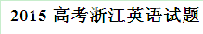
选择题部分(共80分)
第一部分:英语知识运用(共两节，满分30分!
第一节:单项填空(共20小题;每小题0.5分，满分10分)
从A、B、C和D四个选项中，选出可以填入空白处的最佳选项，并在答题纸上将该选项标号涂黑。
1. ——Hi, John. Are you busy?
——
A. Yes.I do agree. B. Yes.That would be nice.
C. No.Are you sure? D. No.What’s up?
【答案】D
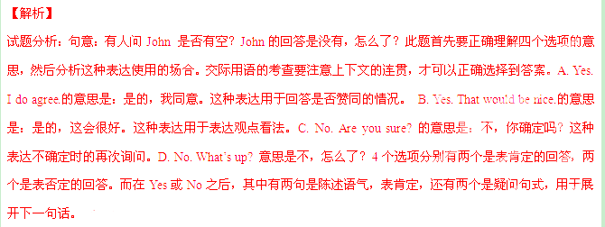考点：考查交际用语
2. Jane’s grandmother had wanted to write children’s book for many years, but one thing or another always got in way.
A. a;不填 B. the;the C. 不填;the D. a;the
【答案】D
【解析】
试题分析：句意：多年来，简的奶奶想写一本有关于儿童的书，但总是被这样或那样的原因阻碍了。第一个空使用不定冠词表泛指，第二个in the way 是固定搭配，意为挡道或阻碍。定冠词用于特指或者是固定搭配，不定冠词用于泛指。
考点：考查冠词的使用
3. Have you ever heard of the trees that are homes animals both on land and sea?
A. about B. to C. with D. over
【答案】 B
【解析】
试题分析：句意：你是否有听说过树是陆上动物和海上动物的家？home to sth 固定搭配，是什么的家园的意思。该句是一个疑问句，其中还含有一个定语从句。比如这个句子转化为陈述句应该是You have ever heard of the trees that are homes animals both on land and sea? 然后把定语从句单独拿出来看将会是trees are homes animals both on land and sea. 根据固定搭配自然知道答案是to。
考点：考查介词
4. It was so noisy that we hear ourselves speak.
A. couldn’t B. shouldn’t C. mustn’t D needn’t
【答案】A
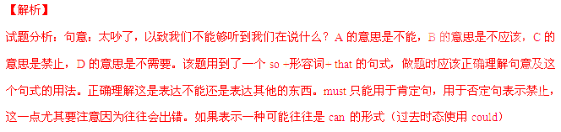考点：考查情态动词
5. Studies have shown that the right and left ear sound differently.
A. produce B. pronounce C. process D. download
【答案】C
【解析】
试题分析：句意：研究已经表明，左耳和右耳处理声音是不同的。A意为生产或制造，B意为发音，C意为处理，D意为下载。该题考查的是词义辨析，4个选项的意思都非常的不一样，所以在作答的时候，要每一个单词都代入空格进行翻译，找出最佳答案。根据常识，耳朵不能够生产或制造，不能发音，更不可能下载。所以答案只能是处理，也就是C。
考点：考查动词
6. If you swim in a river or lake, be sure to investigate is below the water surface. Often there are rocks or branched hidden in the water.
A. what B. who C. that D. whoever
【答案】A

【解析】
试题分析：句意：如果你在河里或湖里游泳，请确定查看水面下有什么？通常总有一些石头或树枝藏在水里。此处的what指代的是树枝或石头，B选项和D选项用于指人，that 只有语法意义。句式上，该句用了(If 从句，祈使句)的句式，非谓语to investigate 后接一个宾语从句的表达。分析宾语从句的成分可以发现，空格所做的成分是主语。根据下一句的表述中的树枝和石头，可以得出答案是what.
考点：考查连词
7. Body language can a lot about your mood, so standing with your arms folded can send out a signal that you are being defensive.
A. take away B. throw away C. put away D. give away
【答案】D
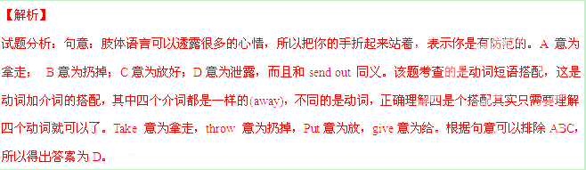考点：考查动词短语搭配
8. Albert Einstein was born in 1879. As a child, few people guessed that he a famous scientist whose theories would change the world.
A. has been B. had been C. was going to be D. was
【答案】C
【解析】
试题分析：句意：爱因斯坦出生于1879年，小的时候很少人猜到他将会成为一个伟大的科学家，他的理论将会改变全世界。根据句意，应该是表达过去将来时，所以只有C选项符合。该选项是使用过去进行时表将来。A选项是现在完成时（用以表达过去的动作对现在的影响，往往有一些关键的词比如说since或者是for加一段时间），B选项是过去完成时(具备的条件是有两个动词，而且其中一个动作要在另一个动作之前发生，那么这个之前发生的动词就使用过去完成时)，C选项是过去进行时（过去进行时表示过去某一此刻正在进行的动作，另外动词going的进行时还可以表达将来），D选项是过去时（表达过去的动作）。结合以上的表述以及后句使用的情态动词would（will 的过去时，用于过去将来时），分析可知答案就是C。
考点：考查动词时态
9. a single world can change the meaning of a sentence, a single sentence can change the meaning of a paragraph.
A. Just as B. Even though C. Until D. Unless
【答案】A
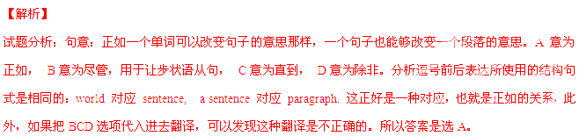考点：考查连词
10. Most people work because it’s unavoidable. , there are some people who actually enjoy work.
A. As a result B. In addition C. By contrast D. In conclusion
【答案】C
【解析】
试题分析：句意：很多人工作是因为这是不可避免的，相反，有一些人是的确喜欢工作的。根据前后的意思，可以知道前后是表示对比。A意为结果， B意为此外， C意为相反， D意为结论。“不可避免”表述到一种无奈，也就是说，很多人是不得不工作的。后句的表达是“事实上有些人喜欢工作”， “喜欢”和“不得不”刚好构成一种否定，所以答案只能是选C。
考点：考查介词短语
11 . We tend to have a better memory for things that excite our senses or our emotions than for straight facts.
A. block off. B. appeal to C. subscribe to D. come across
【答案】B
【解析】
试题分析：句意：我们趋向于对于有一些记忆会比较清楚，这些东西是让我们激动或者是吸引我们的。A. block off.意为封锁， B. appeal to意为吸引， C. subscribe to意为订阅， D. come across意为遇到。该句的句式使用到了一个比较句式以及一个定语从句，看起来有一点复杂，其实这道题的关键就是连词or，or意思是或者，用于并列句。所以 our emotions表达是跟前面excite our senses（让我们激动）意思是相同的，根据句意不难得出答案是C吸引。
考点：考查动词短语。
12. How would you like if you were watching your favorite TV program and someone came into the room and just shut it off without asking you?
A. them B. one C. those D. it
【答案】D
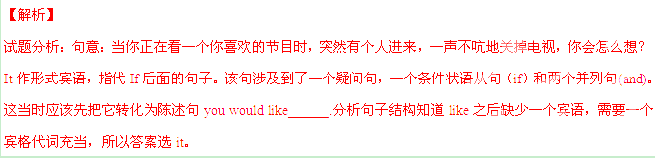考点：考查代词It
13. Most of us, if we know even a little about where our food comes from, understand that every bite put into our mouths was alive.
A. steadily B. instantly C. formerly D. permanently
【答案】C
【解析】
试题分析：句意：就算我们很少了解食物来自于哪里，我们大多数人都明白，放在我们的口里的每一点食物在之前都是活着的。A. steadily意为稳定地， B. instantly意为立即地，C. formerly意为先前地， D. permanently意为永久地。在做题的时候，只需要理解最后一句话就可以了was ______alive. 根据句意及常识不能得出答案，在吃入口中之前的都是活着的。
考点：考查副词
14. Listening is thus an active, not a , behavior consisting of hearing, understanding and remembering.
A. considerate B. sensitive C. reliable D. passive
【答案】D
【解析】
试题分析：句意：因此听是一种主动的，而不是被动的行为。它包含听，理解和记忆。A. considerate意为考虑周全的， B. sensitive意为敏感的，C. reliable意为可靠的，D. passive意为被动的。根据not可以知道前后是反义表达，所以选D。此题的关键是有一个not这是表示否定的，这表明跟前面的active是反义的关系，根据4个选项的意思不能得出答案是 D. passive被动的。
考点：考查形容词

15. One of the most effective ways to reduce is to talk about feeling with someone you trust.
A. production B. stress C. energy D. passive
【答案】B
【解析】
试题分析：句意：一种最有效的减压方法就是和你觉得信任的人谈谈你的想法。A. production意为产品， B. stress意为压力， C. energy意为能源， D. passive意为力量。此题考查的是4个名词的词义辨析，需要正确理解该句的语义。根据常识可以知道，和别人谈心应该来说是减压。所以答案是B. stress意为压力
考点：考查名词
16. If steel is heavier than water, why are ships able to on the sea?
A. float B. drown C. shrink D. split
【答案】A
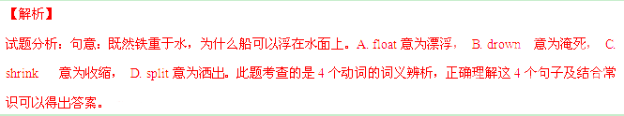考点：考查动词。
17. These comments came specific questions often asked by local newsmen.
A. in memory of B. in response to C. in touch with D. in possession of
【答案】B
【解析】
试题分析：句意：这些评论是对某些经常被当地新闻人问到的问题的回应。A. in memory of 意为纪念， B. in response to意为回应，C. in touch with意为联系，D. in possession of意为拥有。分析句子成分知道空格处充当介词短语作状语的作用，根据常识和句意，评论应该是对问题的回应。所以答案应该是B. in response to回应。
考点：考查介词短语
18. Listening to music at home is one thing, going to hear it live is quite another.
A. perform B. performing C. to perform D. being performed
【答案】D
【解析】
试题分析：句意：在家里面听音乐是一回事，去到现场听又是另一回事。hear sb/sth doing 表听到某人某物做某事。由于音乐是被演奏的，所以需要被动，所以选D。分析4个选项知道，答案所使用的是同一个动词，不同的是时态、语态或者是非谓语形式。 A是动词原形，B是非谓语现在分词形式，C是非谓语的不定式，D是非谓语的现在分词被动形式。分析句子结构以及用法，不难知道音乐是被演奏的，所以需要被动，所以选D。
考点：考查动词非谓语
19. Creating an atmosphere employees feel part of a team is a big challenge.
A. as B. whose C. in which D. at which
【答案】C
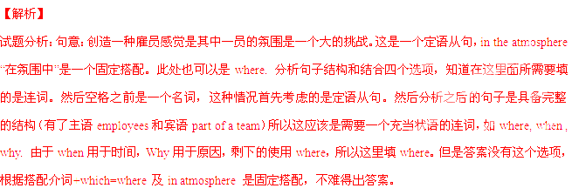考点：考查定语从句介词加which的用法。
20. 一Why don’t you consider a trip to, say, Beijing or Hangzhou?
一 .
A. I wouldn’t mind that B. Then we’ll get there quickly
C. Let’s call it a day D. It’s not a requirement
【答案】A
【解析】
试题分析：句意：-为什么你不考虑一次旅行,比如说去北京或者是杭州? -我是不会介意的。
A. I wouldn’t mind that 意为我是不介意的， B. Then we’ll get there quickly意为然后我们可以快一点到那里，C. Let’s call it a day 意为我们今天就到这儿吧，D. It’s not a requirement意为这不是要求。根据句意，所以选A。解答此题的关键是一定要正确理解句意以及答案的相关性。问题问的是旅游，而且涉及到了两个地方Beijing or Hangzhou，所以答案应该是跟旅游这件事有关的一种表达，选项A的不介意其实是对于北京或者杭州都不介意。根据句意B选项是不用于这种旅游的情况。C是一个固定搭配的形式，它用于结束某一种对话。D项中的it指代不明。
考点：考查交际用语
第二节:完形填空(共20小题;每小题1分，满分20分)
阅读下面短文，掌握其大意，然后从21-40各题所给的四个选项(A, B, C和D)
中，选出最佳选项，并在答题纸上将该选项标号涂黑。
Since finishing my studies at Harvard and Oxford. I’ve watched one friend after another land high-ranking, high-paying Wall Street jobs. As executives(高级管理人员) with banks, consulting firms, established law firms, and major corporations, many are now 21 on their way to impressive careers. By society’s 22 , they seem to have it made.
On the surface, these people seem to be very lucky in life. As they left student life behind, many had a 23 drink at their cheap but friendly local bar, shook hands with Longtime roommates, and 24 out of small apartments into high buildings. They made reservations at restaurants where the cost of a bottle of wine 25 a college year’s monthly rent. They replaced their beloved old car with expensive new sports cars.
The thing is, a number of them have 26 that despite their success, they aren’t happy. Some 27 of unfriendly coworkers and feel sad for eight-hour workweeks devoted to tasks they 28 . Some do not respect the companies they work for and talk of feeling tired and 29 . However, instead of devoting themselves to their work, they find themselves working to support the 30 to which they have so quickly become 31 .
People often speak of trying a more satisfying path, and 32 the end the idea of leaving, their jobs to work for something they 33 or finding a position that would give them more time with their families almost always leads them to the same conclusion; it’ s 34 . They have loans, bills, a mortgage（抵押贷款）to 35 , retirement to save for. They recognize there’s something 36 in their lives, but it’s 37 to step off the track.
In a society that tends to 38 everything in terms of dollars and cents, we learn form a young age to consider the costs of our 39 in financial terms. But what about the personal and social costs 40 in pursuing money over meaning? These are exactly the kinds of us tend to ignore — and the very ones we need to consider most.
21. A. much B. never C. seldom D. well
22. A. policies B. standards C. experiments D. regulations
23. A. last B. least C. second D. best
24. A. cycled B. moved C. slid D. looked
25. A. shared B. paid C. equaled D. collected
26. A. advertised B. witnessed C. admitted D. demanded
27. A. complain B. dream C. hear D. approve
28. A. distribute B. hate C. applaud D. neglect
29. A. calm B. guilty C. warm D. empty
30. A. family B. government C. lifestyle D. project
31. A. accustomed B. appointed C. unique D. available
32. A. yet B. also C. instead D. rather
33. A. let out B. turn in C. give up D. believe in
34. A. fundamental B. practical C. impossible D. unforgettable
35. A. take of B. drop off C. put off D. pay off
36. A. missing B. inspiring C. sinking D. shining
37. A. harmful B. hard C. useful D. normal
38. A. measure B. suffer C. digest D. deliver
39. A. disasters B. motivations C. campaigns D. decisions
40. A. assessed B. involved C. covered D. reduced
【答案】
21.D
22.B
23.A
24.B
25.C
26.C
27.A
28.B
29.D
30.C
31.A
32.A
33.D
34.C
35.D
36.A
37.B
38.A
39.D
40.B
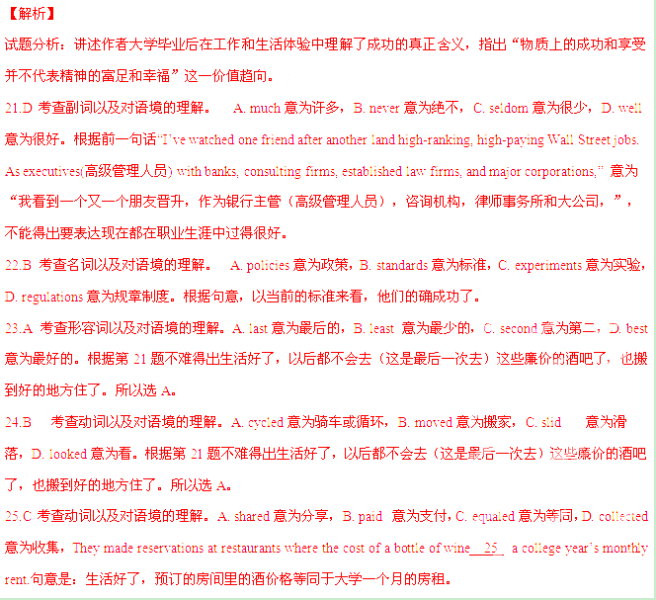26.C 考查动词以及对语境的理解。 A. advertise意为广告，B. witnessed意为目击，C. admitted 意为承认D. demanded意为要求。“The thing is, a number of them have 26 that despite their success, they aren’t happy.” 意为很多人承认，尽管他们很成功，但是很不开心。
27.A 考查动词以及对语境的理解。A. complain意为抱怨，B. dream意为梦想，C. hear 意为听到，D. approve意为证明。根据上一句的不开心，所以不难得出答案是抱怨。
28.B 考查动词以及对语境的理解。A. distribute意为分发，B. hate意为厌恶，C. applaud意为鼓掌，D. neglect意为忽略。根据上文的不开心和抱怨，不能得出答案是厌恶。
29.D 考查形容词以及对语境的理解。A. calm意为平静，B. guilty意为有罪的，C. warm意为温暖，D. empty意为空的，累的。根据前面的tired累不能得出答案。Some do not respect the companies they work for and talk of feeling tired and 29 。意为有些人不尊重他们工作的公司，说累。
30.C 考查名词以及对语境的理解。A. family意为家庭，B. government意为政府，C. lifestyle意为生活方式，D. project意为项目。前文提到很多都是生活，如学校生活，工作生活，结合语境不能得出答案是生活方式。
31.A 考查形容词以及对语境的理解。A. accustomed意为习惯的，B. appointed意为指定的，C. unique意为独一无二的，D. available意为可利用的。“However, instead of devoting themselves to their work, they find themselves working to support the 30 to which they have so quickly become 31 . 意为“但是，不是全身心投入于工作，他们发现工作只是支持生活方式，而且慢慢他们已经对这种方式已经行习惯了。”
32.A 考查连词以及对语境的理解。A. yet意为但是，表转折，B. also 意为也，表递进，C. instead 意为代替，D. rather意为相反。此句是长难句。意为：人们总是说走一种满意的道路，但是最后，离开现在的工作去做一些他们相信或者是一种可以和家人在一起的职务的想法最终都得出一个这样的结论：这是不可能的。根据句意，前后是转折的关系，所以选A。
33.D 考查动词以及对语境的理解。A. let out 意为发出，B. turn in意为上交，归还，C. give up 意为放弃，D. believe in意为相信。此句是长难句。意为：人们总是说走一种满意的道路，但是最后，离开现在的工作去做一些他们相信或者是一种可以和家人在一起的职务的想法最终都得出一个这样的结论：这是不可能的。
34.C 考查形容词以及对语境的理解。A. fundamental意为基本的，B. practical意为实践的，C. impossible意为不可能的，D. unforgettable意为难忘的。此句是长难句。意为：人们总是说走一种满意的道路，但是最后，离开现在的工作去做一些他们相信或者是一种可以和家人在一起的职务的想法最终都得出一个这样的结论：这是不可能的。
35.D 考查动词以及对语境的理解。A. take of 意为起飞，B. drop off 意为减少，C. put off意为推迟，D. pay off意为支付。根据mortgage（抵押贷款）以及结合常识，不难得出答案。
36.A 考查动词以及对语境的理解。A. missing意为失去，B. inspiring意为鼓舞，C. sinking 意为沉没，D. shining意为闪亮。句意是为他们意识到，在生活中失去missing了一些什么，但是他们却很难离开这个轨迹。根据句意不难得出答案。
37.B 考查形容词以及对语境的理解。A. harmful 意为有害的，B. hard 意为困难的，C. useful意为有用的，D. normal意为正常的。句意是为他们意识到，在生活中失去了一些什么，但是他们却很难hard离开这个轨迹。根据句意不难得出答案。
38. A 考查动词以及对语境的理解。A. measure 意为衡量，B. suffer意为遭受，C. digest意为消化，D. deliver意为运送。句意为当前的社会，人们趋向于用钱来衡量measure所有的事情，我们在很小的时候就知道，应该考虑我们决定的经济代价。
39.D 考查名词以及对语境的理解。A. disasters 意为灾难，B. motivations意为动机，C. campaigns意为战役，D. decisions意为决定。句意为当前的社会，人们趋向于用钱来衡量所有的事情，我们在很小的时候就知道，应该考虑我们决定decisions的经济代价。
40.B 考查动词以及对语境的理解。A. assessed意为评估，B. involved意为涉及，C. covered意为覆盖，D. reduced意为减少。Involved in 意为参与。句意为：那么，在追求钱高于意义的情况下，我们的参与的个人以及社会代价呢？
考点：夹叙夹议的一篇文章
第二部分： 阅读理解（第一节共20小题，第二节5小题；每小题2分，满分50分）
阅读下列材料，从每题所给的四个选项（A、B、C和D）中，选出最佳选项，并在答题纸上将该选项标号涂黑。
A
From the very beginning of school we make books and reading a constant source of possible failure and public humiliation. When children are little we make them read aloud, before the teacher and other children, so that we can be sure they “know” all the words they are reading. This means that when they don’t know a word, they are going to make a mistake, right in front of everyone. After having taught fifth-grade classes for four years, I decided to try at all costs to rid them of their fear and dislike of books, and to get them to read oftener and more adventurously.
One day soon after school had started, I said to them, “Now I’m going to say something about reading that you have probably never heard a teacher say before. I would like you to read a lot of books this year, but I want you to read them only for pleasure. I am not going to ask you questions to find out whether you understand the books or not. If you understand enough of a book to enjoy it and want to go on reading it, that’s enough for me. Also I’m not going to ask you what words mean. “
The children sat stunned and silent. Was this a teacher talking? One girl, who had just come to us from a school where she had had a very hard time, looked at me steadily for a long time after I had finished. Then, still looking at me, she said slowly and seriously, Mr Holt, do you really mean that?” I said just as seriously, “I mean every word of it.
During the spring she really astonished me. One day, she was reading at her desk, From a glimpse of the illustrations I thought I knew what the book was. I said to myself, “It can’t be,” and went to take a closer look. Sure enough, she was reading Moby Dick , in edition with woodcuts. I said, “Don’t you find parts of it rather heavy going?” She answered, Oh, sure, but I just skip over those parts and go on to the next good part. “
This is exactly what reading should be and in school so seldom is, an exciting, joyous adventure. Find something, dive into it, take the good parts, skip the bad parts, get what you can out of it, go on to something else. How different is our mean-spirited, picky insistence that every child get every last little scrap of “understanding” that can be dug out of a book.
41. According to the passage, children’s fear and dislike of books may result from________.
A. reading little and thinking little
B. reading often and adventurously
C. being made to read too much
D. being made to read aloud before others
42. The teacher told his students to read______ .
A. for enjoyment B. for knowledge
C. for a larger vocabulary D. for higher scores in exams
43. Upon hearing the teacher’s talk, the children probably felt that________.
A. it sounded stupid
B. it was not surprising at all
C. it sounded too good to be true
D. it was no different from other teachers' talk
44. Which of the following statements about the girl is TRUE according to the passage?
A. She skipped over those easy parts while reading.
B. She had a hard time finishing the required reading tasks.
C. She learned to appreciate some parts of the difficult books.
D. She turned out to be a top student after coming to this school.
45. From the teacher's point of view,_________ .
A. children cannot tell good parts from bad parts while reading
B. children should be left to decide what to read and how to read
C. reading is never a pleasant and inspiring experience in school
D. reading involves understanding every little piece of information
【答案】
41.D
42.A
43.C
44.C
45.B
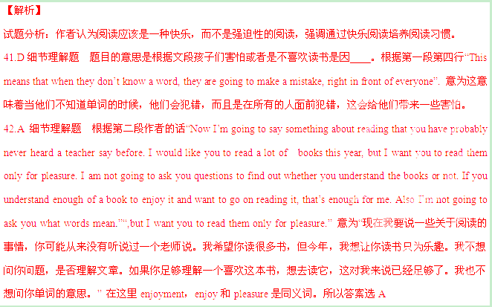43. C细节理解题 根据“The children sat stunned and silent. 孩子们震惊和沉默地坐着。”第三段第四行“seriously, ‘Mr. Holt, do you really mean that?’”不能得出答案。当老师说了这些话之后，孩子们都很震惊耶，很奇怪，所以他会确定问老师是不是真的这样？这表明学生是很不太相信的。答案选项的it sounded too good to be true，意为听起来太好了以致不相信这是真的。
44. C细节理解题这种题目是判断正误题，答题时一定要细心选择是错误还是正确的。此题选择的是正确的，也就意味着有3个是错误，只有一个是正确的。根据第四段最后一句话“She answered, Oh, sure, but I just skip over those parts and go on to the next good part. “她回答说，哦，当然，但我只是跳过这些部分，继续读下一个好的部分。“可以得出答案是这个女孩知道如何欣赏这些文章。
45. B细节理解题 四个选项的意思分别是A孩子在阅读的时候不能够区别好的部分以及不好的部分；B应该留给学生孩子自己去选择，读什么以及如何读；C在学校阅读永远不会是一个愉快和启发性的体验；D阅读需要理解每一部分的信息。其实根据常识可以判断C和D是错误的，然后再结合全文大意，作者认为孩子不应该是强迫去读，要让他们自己读，选择材料读。
考点： 这是一篇记叙文。
B
Graph can be a very useful tool for conveying information especially numbers， percentages, and other data . A graph gives the reader a picture to interpret. That can be a lot more pages and pages and pages explaining the data .
Graphs can seem frightening, but reading a graph is a lot like reading a story. The graph has a title ,a main idea ,and supporting details .You can use your active reading skills to analyze and understand graphs just like any other text .
Most graphs have a few basic parts: a caption or introduction paragraph, a title , a legend or key, and labeled axes. An active reader looks at each part of the graph before trying to interpret the data. Captions will usually tell you where the data came from (for example, a scientific study of 400 African elephants from 1980 to 2005). Captions usually summarize the author's main point as well. The title is very important. It tells you the main idea of the graph by stating what kind of information is being shown. A legend, also called a key ,is a guide to the symbols and colors used in the graph. Many graphs, including bar graphs and line graphs, have two axes that form a corner, Usually these axes are the left side and the bottom of the graph .Each axis will always have a label. The label tells you what each axis measures.
Bar Graphs
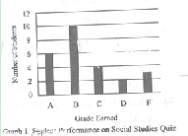
A bar graph has two axes and uses bars to show
amounts. In Graph 1 ,we see that the x-axis shows grades
that students earned, and the y-axis shows bow many
students earned each grade .You can see that 6 students
earned an A because the bar for A stretches up to 6 on the
vertical measurement. There is a lot of information we can
get from a simple graph like this(See Graph 1).
Line Graphs
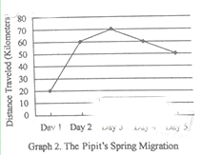
A line graph looks similar to a bar graph ,but instead of
Bars, it plots points and connects them with a line .It has the same parts as a bar graph – two labeled axes –and can be read the same way .To read a line graph, it’s important to focus on the points of intersection rather than the line
segments between the points, This type of graph is most
commonly used to show how something changes over time.
Here is a graph that charts how far a bird flies during the first Five days of its spring migration (See Graph 2).
The unit of measurement for the x-axis is days. The unit of measurement for the y-axis is kilometers. Thus we can see that ,on the first day, the pipit flew 20 kilometers. The line segment goes up between Day 1 and Day 2,which means that the bird flew farther on Day 2.If the line segment angled dawn, as between Day 4 and Day 5,it would mean that the bird flew fewer kilometers than the day before. This line graph is a quick, visual way to tell the reader about the bird’s migration.
Pie Graphs
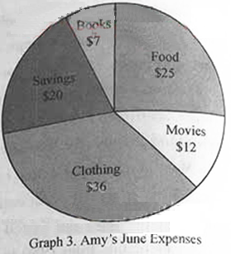
A typical pie graph looks like a circular pie. The circle is divided into sections, and each section represents a fraction of the data. The graph is commonly used to show percentages; the whole pie represents l00 percent, so each piece is a fraction of the whole.
A pie graph might include a legend，or it might use icons or labels within each slice. This pie graph shows on month’s expense, (See Graph 3 ).
Food $ 25
Movies $ 12
Clothing $ 36
Savings $ 20
Books $ 7
46. When used in a graph，a legend is_____
A. a guide to the symbols and colors B. an introduction paragraph
C. the main idea D. the data
47. What is the total number of students who earned a C or better ?
A .4. B.6. C.10. D.20 .
48. The bird covered the longest distance on _____
A. Day 1 B. Day 2 C. Day 3 D. Day 4
49. Which of the following cost Amy most ?
A. Food. B. Books C. Movies D. Clothing.
【答案】
46.A
47.D
48.C
49.D
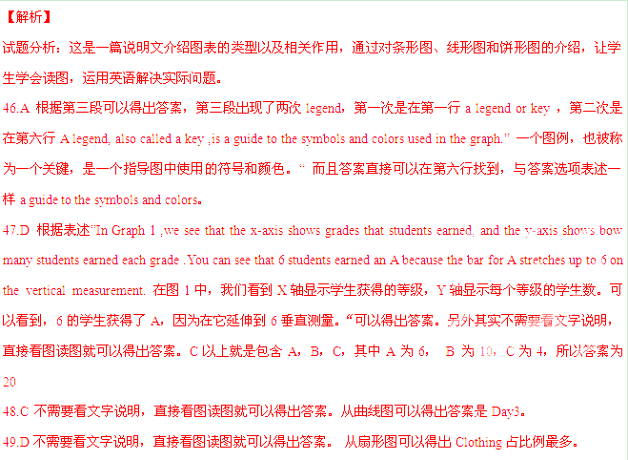考点：说明文
C
If humans were truly at home under the light of the moon and stars，we would go in darkness happily，the midnight world as visible to us as it is to the vast number of nocturnal(夜间活动的) species on this planet. Instead，we are diurnal creatures, with eyes adapted to living in the sun’s light. This is a basic evolutionary fact, even though most of us don’t think of ourselves as diurnal beings. Yet it’s the only way to explain what we’ve done to the night: We’ve engineered it to receive us by filling it with light.
The benefits of this kind of engineering come with consequences 一 called light pollution 一 whose effects scientists are only now beginning to study. Light pollution is largely the result of bad lighting design，which allows artificial light to shine outward and upward into the sky. III-designed lighting washes out the darkness of night and completely changes the light levels 一 and light rhythms — to which many forms of life, including, ourselves, have adapted. Wherever human light spills into the natural world, some aspect or life is affected .

In most cities the sky looks as though it has been emptied of stars, leaving behind a vacant haze(霾) that mirrors our fear of the dark. We’ve grown so used to this orange haze that the original glory of an unlit nigh, - dark enough for the planet Venus to throw shadow on Earth, is wholly beyond our experience, beyond memory almost.
We’ve lit up the night as if it were an unoccupied country, when nothing could be further form the truth. Among mammals alone, the number of nocturnal species is astonishing, Light is a powerful biological force, and on many species it acts as a magnet(磁铁). The effect is so powerful that scientists speak of songbirds and seabirds being “captured” by searchlights on land or by the light from gas flares on marine oil platforms. Migrating at night, birds tend to collide with brightly lit tall buildings.
Frogs living near brightly lit highways suffer nocturnal light levels that are as much as a million times righter than normal, throwing nearly every aspect of their behavior out of joint including most other creatures ,we do need darkness .Darkness is as essential to our biological welfare, to our internal clockwork, as light itself.
Living in a glare of our making,we have cut ourselves off from our evolutionary and cultural heritage—the light of the stars and the rhythms of day and night .In a very real sense light pollution causes us to lose sight of our true place in the universe, to forget the scale of our being, which is best measured against the dimensions of a deep night with the Milky Way—the edge of our galaxy arching overhead.
50. According to the passage, human being .
A. prefer to live in the darkness
B. are used to living in the day light
C. were curious about the midnight world
D. had to stay at home with the light of the moon
51. What does “it”(Paragraph 1) most probably refer to?
A. The night. B. The moon C. The sky D. The planet
52. The writer mentions birds and frogs to .
A. provide examples of animal protection
B. show how light pollution affects animals
C. compare the living habits of both species
D. explain why the number of certain species has declined
53. It is implied in the last paragraph that .
A. light pollution dose harm to the eyesight of animals
B. light pollution has destroyed some of the world heritages
C. human beings cannot go to the outer space
D. human beings should reflect on their position in the universe
54. What might be the best title for the passage?
A. The Magic light. B. The Orange Haze.
C. The Disappearing Night. D. The Rhythms of Nature.
【答案】
50.B
51.A
52.B
53.D
54.C
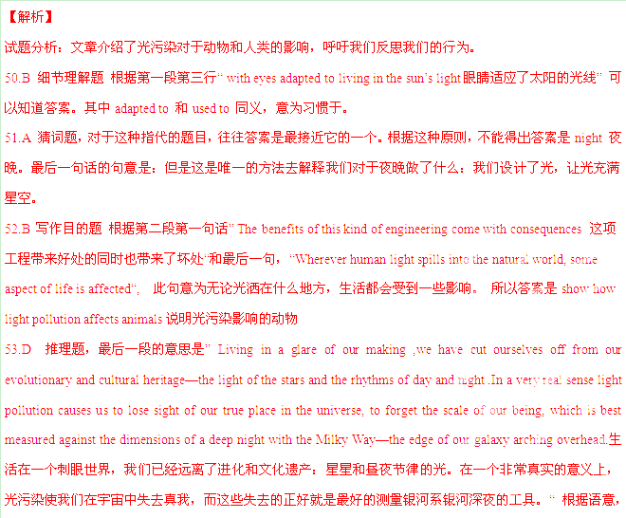不难得出答案是D. human beings should reflect on their position in the universe人类应该反思自己的行为。但此题易错选B，之所以不选B是因为some of 的表达是扩大了说法，以偏概全。
54.C 标题题，根据，文章出现最多的就是light和night, 我们可以知道答案是C。之所以不选A，是因为它所使用的形容词Magic意思是奇幻的，这个单词具有褒义的意思。而C选项的disappearing 是消失的，这符合本文的语境，让我们反思。
考点：这是一篇夹叙夹议的文章
D
In 2004 ,when my daughter Becky was ten , she and my husband ,Joe, were united in their desire for a dog . As for me , I shared none of their canine lust.
But why , they pleaded. “Because I don’t have time to take care of a dog.” But we’ll do it. ” Really? You’re going to walk the dog? Feed the dog? Bathe the dog?” Yes, yes , and yes .”I don’t believe you .” We will . We promise.
They didn’t . From day two (everyone wanted to walk the cute puppy that first day ) , neither thought to walk the dog . While I was slow to accept that I would be the one to keep track of her shots , to schedule her vet appointments , to feed and clean her , Misty knew this on day one . As she looked up at the three new humans in her life (small, medium, and large) , she calculated ,”The medium one is the sucker in the pack .”
Quickly, she and I developed something very similar to a Vulcan mind meld (心灵融合) . She’d look at me with those sad brown eyes of hers , beam her need , and then wait , trusting I would understand — which , strangely , I almost always did . In no time , she became my feet as I read , and splaying across my stomach as I watched television .
Even so , part of me continued to resent walking duty . Joe and Becky had promised. Not fair , I’d balk (不心甘情愿地做) silently as she and I walked . “Not fair , ” I’ d loudly remind anyone within earshot upon our return home .
Then one day — January 1, 2007 , to be exact — my husband ‘ s doctor uttered an unthinkable word : leukemia ( 白血病) .With that , I spent eight to ten hours a day with Joe in the hospital , doing any22thing and everything I could to ease his discomfort. During those six months of hospitalizations, Becky, 12 at the time, adjusted to other adults being in the house when she returned from school. My work colleagues adjusted to my taking off at a moment's notice for medical emergencies. Every part of my life changed; no part of my old routine remained.
Save one: Misty still needed walking. At the beginning, when friends offered to take her
through her paces, I declined because I knew they had their own households to deal with.
As the months went by，I began to realize that I actually wanted to walk Misty. The walk in the morning before I headed to the hospital was a quiet, peaceful time to gather my thoughts or to just be before the day's medical drama unfolded. The evening walk was a time to shake off the day's upsets and let the worry tracks in my head go to white noise.
When serious illness visits your household, it's , not just your daily routine and your assumptions about the future that are no longer familiar. Pretty much everyone you acts differently.
Not Misty. Take her for a walk, and she had no interest in Joe's blood counts or ’one marrow test results. On the street or in the park, she had only one thing on her mind: squirrels! She Was so joyous that even on the worst days, she could make me smile. On a daily basis she reminded me that life goes on.
After Joe died in 2009，Misty slept on his pillow.
I'm grateful一to a point. The truth is, after years of balking, I've come to enjoy m’ walks with Misty. As I watch her chase after a squirrel, throwing her whole being into the here-and-now of an exercise that has never once ended in victory, she reminds me, too, that no matter how harsh the present or unpredictable the future , there's almost always some measure of joy to be extracted from the moment.
55. why didn't the writer agree to raise a dog at the beginning of the story?
A. She was afraid the dog would get the family, into trouble.
B. It would be her business to take care of the dog
C. Her husband and daughter were united as one.
D. She didn't want to spoil he’ daughter.
56. Which of the following is the closest in meaning to "The medium one is “he sucker in the pack.” (Paragraph 3)?
A. "The middle-aged person loves me most.”
B. ”The medium-sized woman is the hostess.”
C. "The man in the middle is the one who has the final say.”
D. "The woman is the kind and trustworthy one in the family.”
57. It can be inferred from Paragraph 3 that_______.
A. Misty was quite clever
B. Misty could solve math problems
C. the writer was a slow learner
D. no one walked Misty the first day
58. The story came to its turning point when________.
A. Joe died in 2009
B. Joe fell ill in 2007
C. the writer began to walk the dog
D. the dog tired to please the writer
59. Why did the writer continue to walk Misty while Joe was in hospital?
A. Misty couldn’t live without her
B. Her friends didn’t offer any help
C. The walk provided her with spiritual comfort.
D. She didn't want Misty to ’others companion.
60. What is the message the writer wants to convey in the passage?
A. One should learn to enjoy hard times.
B .A disaster can change everything in life.
C. Moments of joy suggest that there is still hope ahead.
D. People will change their attitude toward you when you are in difficulty.
【答案】
55.B
56.D
57.A
58.B
59.C
60.C
【解析】
试题分析：这是一篇记叙文，讲述作者从遛狗的体验中悟出生活的哲理——尽管有时生活艰难、前途难测，但人生总有希望和快乐。
55.B 细节理解题 根据第三段第二行“While I was slow to accept that I would be the one to keep track of her
shots, to schedule her vet appointments, to feed and clean her“作者慢慢地意识到她要去接父女俩的手尾，比如
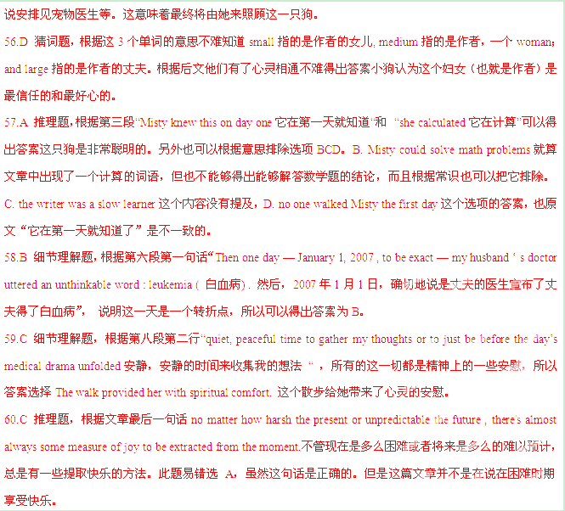考点：记叙文
第二节:下面文章中有5个段落需要添加首句(第61-65题)。请从以下选项(A, B, C,
D, E和F)中选出适合各段落的首句，并在答题纸上将相应选项的标号涂黑。选项中有一项是多余选项。
A. Come in with something to say.
B. Prepare general comments.
C. Bring materials with you.
D. Don’t make them wait.
E. Have no fear.
F. Go it alone.

One of the best things you can do any time in the semester is go see the professor. So hoof on over to an office hour and have some one-on-one face time with someone who’ll help you master the material and improve your grade, to boot. But how should you have this conversation with the professor? Here are five insider tips about how to make that office hour really count:
61. No need to get all bent out of shape about going to see the professor. The professor would actually like to see you and answer your questions. Believe it or not, he or she is on your side and is eager to see you do well. And besides, he or she has seen many students stupider than you, so nothing you’re gong to ask will set the record for stupidity.
62. Even though you might feel more comfortable going with a friend or partner, the office hour will go better if it’s just you and the professor. You’ll get in more questions, the discussion will be tailored to what you need most help on, and two-party communication is almost always more productive than committee work. You friend can wait outside for the discussion.
63. If you can’t make the official office hours, most professors are willing to make individual, appointments to help you out. If you’re lucky enough to land such an accommodation, though, be sure you’re 100 percent on time. There’s nothing that ticks off a professor more than making him-or herself available for a custom office hour only to find that you don’t care enough to come on time. And besides, the professor might leave after ten minutes, which would make your trip a total loss.
64. If you’re meeting with the professor to go over a paper or test, or to ask questions about a particular lecture or reading, make sure you bring that paper or test, or your lecture notes or a copy of the article. The professor doesn’t remember the comments he or she wrote on your individual piece of work—though he or she will be able to recall them after just a brief glance at your work. And if you have your lecture notes or the article in hand, you and the professor will be able to examine specific points that are confusing to you, rather than just talking in a general way about the contents.
65. Office hours almost always go better if you bring a few specific questions to the meeting. It’s almost never good to start a meeting with general comments such as: “I didn’t understand what you said about [main topic of the course]”or “I couldn’t understand any of your lectures last week.” Much better is to come in with two or three conversation-starters, about a specific concept, point, or problem you didn’t understand. Keep in mind that in a fifteen-minute office hour (which is how long these things usually last), two or three questions are usually the most you’ll have time to discuss.
【答案】
61.E
62.F
63.D
64.C
65.A
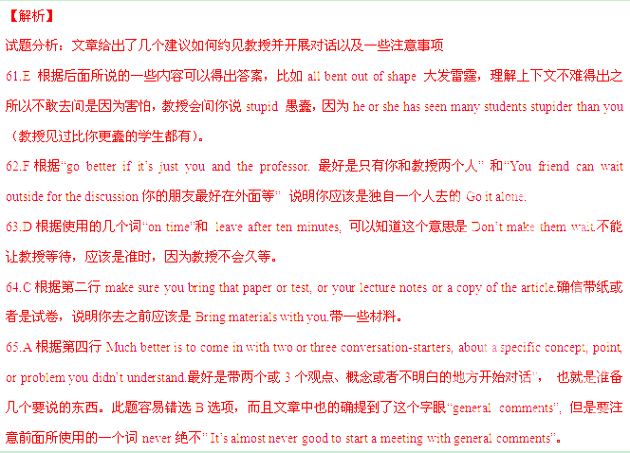考点：语篇段落题
非选择题部分（共40分）
第三部分：写作（共两节，满分40分）
第一节：短文改错（共10小题；每小题1分，满分10分）
下面短文中有10处语言错误。请在有错误的地方增加、删除或修改某个单词。
增加：在缺词处加一个漏字符号（∧），并在其下面写上该加的词。
删除：把多余的词用斜线（﹨）划掉。
修改：在错的词下画一横线，并在该词下面写出修改后的词。
注意：1.每处错误及其修改均仅限一词；
2.只允许修改10处，多者（从第11处起）不计分。

例如：
It was very nice to get your invitation to spent∧weekend with you. Luckily
the
I was completely free then, so I’ll to say “yes”. I’ll arrive in Bristol at around 8:00 p.m.
am
in Friday evening.
On

My old classroom was interesting because three side of the classroom were made from glass. I enjoyed sit close to the windows and looking at the view. On the left-hand side of the class, I could easy see the football field. In the mornings, it was full of students exercising. The view from the back of the classroom is also splendid. Close to the school there was a beautiful park with many trees around them. Farther in the distance, I could not enjoy the view of snowy mountains. On the right side of the class was the road. I was always interested to see the drivers in hurry in the morning. The position of the classroom with its view made me felt like I was dreaming. If I was only a child when I studied in that classroom, I will never forget it.
【答案】
side-sides
from-to
sit-sitting
easy-easily
is-was
them-it
not 删除
in hurry- in a hurry
felt-feel
If-Although/Though
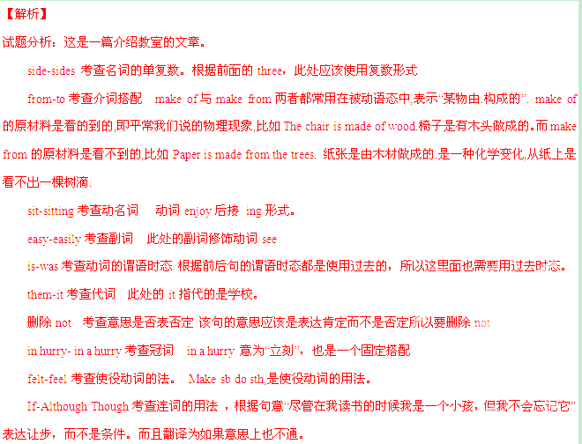考点：短文改错
第二节：书面表达（满分30分）
在班级活动中，当你的想法与大多数同学不一致时，你是坚持自己的观点并说服别人，还是尊重大多数同学的意见？请你以“When I Have a Different Opinion”为题，用英文写一篇100～120个词“短文。要求如下：
1.从以上两种做法中选择一种；
2.以具体事例阐述你选择的理由。
注意：短文中，不得以任何形式透露地区、学校、同学姓名等真实信息。否则，按考试作弊行为认定。
When I Have a Different Opinion

【参考答案】
When I Have a Different Opinion
We may have different opinions in organizing class activities. We may have various ways to deal with such a situation. When I have a better idea, I would choose to stick to it . By doing so, I can not only share good ideas with others but also learn to express myself clearly.
Once we were discussing where to go for an outing. Most of my classmates wanted to go to a park while I had an idea of going to a nicer peace. I managed to persuade my classmates into accepting my idea. We did have a good time that day . Good opinions are worth sticking to because they can benefit us all.

An alternative student version:

When I Have a Different Opinion
We may have different opinions in organizing class activities. When I have a different opinion, I may choose to give it up and respect the opinion of the majority.
The main reason for my choice is that being brought up in a culture emphasizing collectivism; I tend to sacrifice my own interest for the group benefit. Once we were left to decide whether to have a picnic in a park or go to a museum. I would love to go to a museum, but most of my classmates wanted to go for a picnic. Without hesitation, I decided to follow them and we did have lots of fun that day. Sometimes giving up a little can mean getting more.
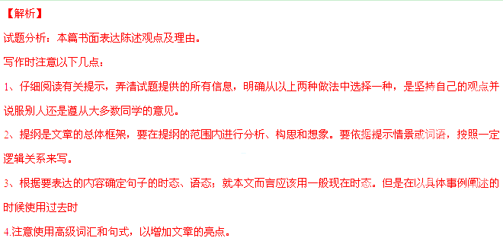【亮点说明】本文结构紧凑，层次分明，而且使用了多种句式和结构。比如not only …but also…不仅而且。
运用连词while 表对比观点。运用because 表达原因。
运用了表语从句表达原因The main reason for my choice is that …。
运用了宾语从句 decide whether do have a … ；discuss where to go for an outing
运用了介词短语 By doing so, Without hesitation.
运用了强调句 we did have a lots of fun that day.
此外，文章还使用了大量习语和短语，如be worth doing sth; stick to sth.; have a good time; have lots of fun ,
tend to do 等。
考点：考查观点理由。

